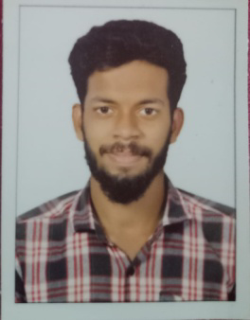
AFSAL S

Noor Manzil
Mekone , Chandhanathpe,
Kollam, Kerala - 691014
Ph:6238662091 | Email: afsalsalim97@gmail.com

OBJECTIVE

To obtain a challenging position in a progressive company, utilizing abilities developed through experience and education , with the opportunities for professional growth based on performance.

EXPERIENCE

- Currently Working as Trainer in Valiyath Institute of Medical Science , Karunagappally, Kerala | From June 2022
- Site Supervisor at Mulamoottil Construction , Thiruvalla (Railway) | From 2019 Sep -2022 June
EDUCATION

Certification in Hospital Administration Affiliated to TUV SUD certified. | ISSD(International School Of Skill Development) | 2022
KGCE(Civil Engineering) | The V Private ITI , Kollam | 2017-2019
Higher Secondary Education (11th,12th) | Govt HSS Mangad, Kollam | 2014-2016

PERSONAL SKILLS  - Verbal Communication  - Multi Tasking  - Computer Knowledge  - Willing to learn  - Work under pressure, Sincere | PERSONAL DATA  - Date of birth : 05.11.1997  - Nationality : India  - Religion : Islam  - Gender : Male  - Language known : Malayalam, English, Tamil and Hindi

DECLARATION

I solemnly declare that all the above information is correct to my knowledge and belief
AFSAL S

