A
BINU K.R

Kondoor House 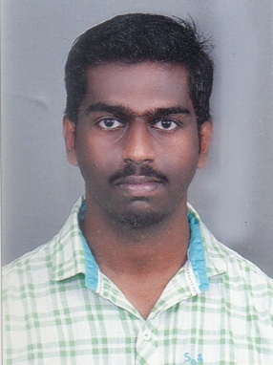
Peroor P O
Kottayam Dist.,
Kerala – 686 637
India.
Ph : 0481 2719824,
Mob 6238032533
Email : binukr19@gmail.com

CAREEROBJECTIVE

To work in an organization that provides me with a challenging environment that encourage me to give my best and values hard work sincerity and loyality.

PROFESSIONAL QUALIFICATION AND ACADEMIC RECORDS

- Diploma in radiology &imaging technology from Mangalam College of Allied Health Science, Affiliated by Punjab Tchnical University.

- Passed Senior Secondry School Examination , National Institute of Open Schooling,Govt. of India
- Passed S.S.L.C Kerala State Board from M T S H S S, Kottayam.

AREA OF INTEREST

- X ray ,CT or MRI

LANGUAGES KNOWN

- English,, Malayalam , Hindi

PERSONAL DETAILS

Father’s Name : Ramankutty K.R
Mother’s Name : Omana Ramankutty
Religion & Caste : Hindu,Ezhava
Marital Status : Single
Date of Birth : 07-11-1993
Sex : Male

WORK EXPERIENCE

- 1 year experience in x-Ray , CT scan and MRI from BCF Indo American hospital, chemmanakary, Vaikom
- 8 month CT experience from Malabar Scans & Research Centre, tirur, malappuram
- 1and half year CT experience from Life scan ,M A J hospital campus, Edappally
- 1year experience in x ray and ct scan from karuna medical college chittur,palakkad.
- 1year experience in mri , ct scan muthoot diagnostics, from thiruvalla

HOBBIES & INTEREST

- Playing Cricket
- Listening to Music

DECLARATION

I here declare that the above mentioned information are true and correct to the best of myknowledge and belief.

Date:29/01/2020
Place: Kottayam Binu K.R

