Terin Rose Varghese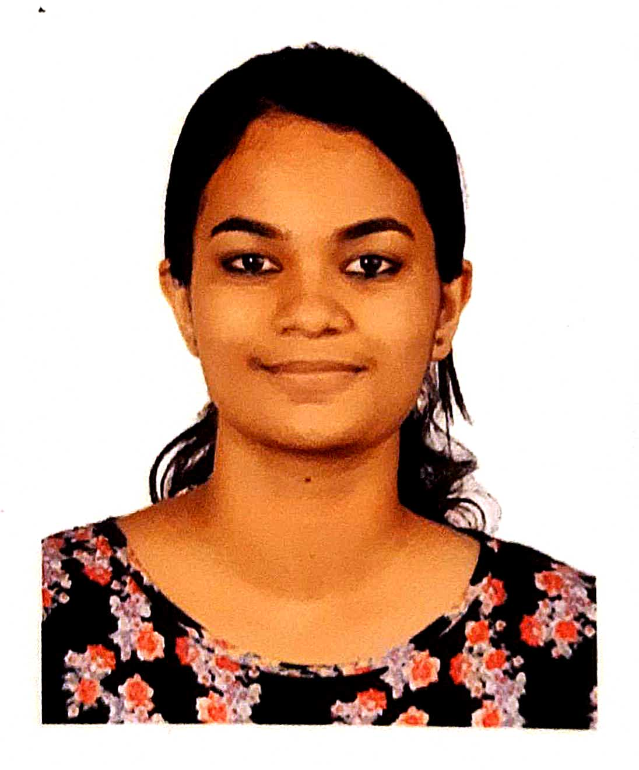
Doctor
Address Kochi, 682023
Phone 8137835873
E-mail trvyb98@gmail.com

Compassionate doctor with knowledge in treating basic conditions. Highly communicative and positive professional.Hardworking and passionate job seeker with strong organizational skills eager to secure entry-level junior resident position. Ready to help team achieve company goals.

Skills
Patient counseling
Advanced

Pediatrics
Upper intermediate

Chart review
Advanced

Insurance form filling
Advanced

Discharge summary,death summary,transfer summary
Advanced

Emergency medical care ,basic management and referral
Upper intermediate

ACLS ,BLS provider

Work History
 | Aug 2021 - Sep 2022 | House Surgeoncy  Amala Institute Of Medical Sciences, Thrissur  - Carried out day-to-day duties accurately and efficiently.  - Maintained excellent attendance record, consistently arriving to work on time.  - Evaluated patient histories, complaints and current symptoms.  - Teamed with other physicians, specialists and health care providers to provide well-rounded care for complex cases.  - Adhered to universal precautions and other appropriate infection control practices.  - Interviewed patients concerning physical complaints, discussed symptoms, asked questions and suggested treatment options.  - Provided emergent medical care and treatment for life-threatening injuries and illnesses.  - Actively participated in patient counselling.

Education
 | Jun 2003 - Mar 2016 | Grade 12  Gregorian Public School - Maradu

 | Aug 2016 - Sep 2022 | Mbbs: Mbbs  Amala Institute of Medical Sciences - Amala Nagar

Accomplishments
acquired ACLS and BLS certification.
actively participated in ARISE programme for creating awareness regarding first aid and cpr in common people.
volunteered for surgery conference RAINS 2018 and 2019.
actively participated in college arts and sports festivals

Languages
English

Malayalam

Hindi

Certifications
 | Aug 2022 | ACLS,BLS provider

Interests
Music,dance,basketball,throwball

