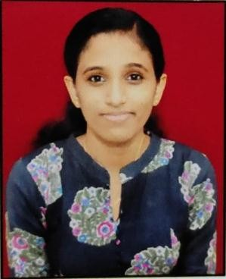
AINA SARA PRINCE

Karippelil house Rayamangalam P.O Ernakulam District
Email: ainasara97@gmail.com

Kerala.PIN Code: 683545
Mobile: +91-7034747292

CAREER OBJECTIVE:
To further my career in the Nursing Field and to utilize my Nursing skills to the
fullest, assisting the physicians in providing the best care possible, patient education, and to be a patient advocate.

ACADEMIC REVIEW:

Course | Specializati on | Name of the Institution | Universi  ty/ Board | Year of Study | Aggregat e (%)
B.S.C | Nursing | Rev.Noorunisa college of Nursing Andersonpettu,KG F, Kolar,Karnataka | Rajeev Gandhi | 2015-  2019 | 85
VHSE | Biology Science Group (Physics, Chemistry, Biology and Math’ s) | VHSS Iringol , Ernakulam , Kerala | VHSE | 2013-  2015 | 70
SSLC | - | Jayakeralam HS Ernakulam , Kerala | SSLC | 2013 | 80

Working Experience

Position | Hospital name | Year of Experience
Junior Staff Nurse | RLKC Metro Hospital, New Delhi :  Worked in General Ward, handled 7 beds. | 18.12.2019 to 24-12-2020
Staff Nurse | ASTER MIMS KOZHIKODE Medical ICU | 24.05.2021 to 05.10.2021
Staff Nurse | ASTER MIMS KOZHIKODE  Department - Peadiatric Cardiac  ICU | 07.11.2021 to 02.08.2022

NURSING REGISTRATION DETAILS

- REG.NO. 15N4522 (RAJIV GANDHIUNIVERSITY)
LANGUAGES KNOWN

English,
  - Malayalam,
  - Hindi,

Hobbies
- Listening toMusic
- Reading
- Liturgy
- Cooking
- WatchingMovies

REFERENCE

RATHEESH
NURSING SUPERINTENDENT
RLKC METRO HOSPITAL DELHI

PERSONAL SKILLS AND COMPETENCIES

- Good communicationskills.
- Quicklearnerandcaneasilyadapttonewandchangingsituations.
- Quickly establish and maintain effective rapport with individuals of diverse backgrounds.
- Abilitytoaccepthonestcriticismconsideringitasapowerfultooloflearning.
- Enthusiastic in areas where networking isinvolved.

PERSONAL PROFILE:

NAME : AINA SARAPRINCE
FATHER’SNAME : PRINCE KC
DATEOFBIRTH :08-08-1997
GENDER :FEMALE
MARITALSTATUS :SINGLE
RELIGION :CHRISTIAN

DECLARATION:
I hereby declare that the above written particulars are true, complete and correct to the best of my knowledge andbelief.

Place:PERUMBAVOOR AINA SARAPRINCE

Date :

