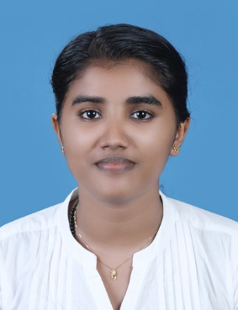 BETZY ELIZABETH GEORGE(23)
KARIPPURATHU PUTHEN VEEDU,KUNNATHUMKARA (P.O) EAST OTHERA , THIRUVALLA,PATHANAMTHITTA,KERALA
Phone: 9108147374
E-mail: betzyelizabethgeorge@gmail.com

Personal details
A highly motivated individual with a degree of physiotherapy . Well versed with required skills with excellent client facing skills and the ability to work closely with others professionals to assess a patient’s needs and devise a suitable plan.
Education
Bachelor of physiotherapy(Rajiv Gandhi University) – Srinivas medical college , Pandeshwar, Manglore (2017-2022)
Higher secondary – St. Thomas high secondary school ,Thiruvalla, Kerala ( 2015 -2017)

Experience/Internship
Srinivas medical college, mukka, manglore( 2 months) – Diagnosed , assessed and treated patient’s physical problems and conditions .
Rehabilitation for ICU patients those who are facing neurological , orthopedic , gynecological and cardio problems.
Spandan special school, mukka, manglore ( 1 month) – diagnosed , assessed and treated children with developmental disabilities.
Preshanth nivas old age home, kankanady, manglore( 1 month) – treated for neuro and ortho conditions in geriatric population.
Courses /seminars /conference
Annual conference of the Indian association of physiotherapists ( 2020)
Course on mechanical radiological differential diagnosis and its myokinetic therapy in musculoskeletal disorders .(2022)
National level conference on “ holistic approach to healthy aging and geriatric rehabilitation”
Workshop on mechanical , radiological differential diagnosis and myokinetic therapy in musculoskeletal disorders.

Workshop on dry needling ( 2020)
International certificate for manual therapy ( 2022)
Skills
- MANUAL THERAPY
- DRY NEEDLING
- TAPING
- MYOFACIAL RELEASE

LANGUAGE
Malayalam
English
Hindi
Tamil

