DR.ANUSREE JAYAMOHAN
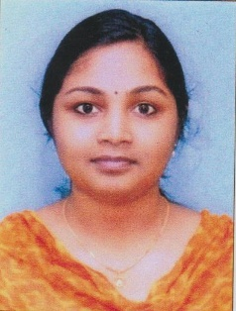
Alappuzha, Kerala 7907269400 anusree.jayamohan007@gmail.com

OBJECTIVE

Seeking a position to start my career in hospitality sector for the mutual growth and profit where I could get learning environment.

EXPERIENCE

- Currently working in vps Lakeshore as junior resident in liver transplant department.
- Worked as medical officer at primary health centre, cheppad from April 1 2020 to October 31 2021.
- Worked as an Intern in Azeezia medical college from July’2017 to june'2018.
- Presented a thesis on gender equality in ICMR headquarters New Delhi as a part of NCS scheme.
- Had taken health education programs in schools for adolescent age group.

Responsibilities Handled
- Diagnosing the disease as per the symptoms.
- Observing and performing the examination of samples for disease diagnose.
- Learning the diagnostic methods and equipments.
- Periodically meeting the patients and observing their improvements and making reports.
- In case of emergency giving the basic treatment to the patients.
- Helping other medical staff in performing their duties.
- Assisting senior doctors
- COVID patient care and supervised vaccination.

EDUCATION

MBBS from Azeezia medical college in year 2017 with 67 %.
Higher secondary from government school Kalavoor in year 2011 with a plus grade. High school from St.josephs school Alappuzha in year 2009 with a plus grade.
Certification And Licensure
- Kerala university of health science- faculty of medicine, 2017-present
- Travancore cochin medical council -2018

SKILLS

- Polite and soft in nature.
- Good verbal and written communication skills.
- Good command over handling the medical equipments.
- Punctual.
- Disciplined.

INTERESTS

- Photography
- Travelling
- Gardening
- Reading books.
- Dancing
- Monoacts.

STRENGTH

- Good theoretical knowledge.
- Excellent communication skills.
- Good knowledge of clinical practices and protocols.
- Ability to handle different types of patients in critical situations.
- Flexible and adaptable.
- Extremely motivated towards career.
- Quick Learner.

CONFERENCE

- Pediatrics
- Dermatology
- Radiology

PERSONAL INFORMATION

- Gender: female
- Nationality: Indian
- Address: Kuttickal house, kattoor p o, kalavoor, Alappuzha, 688522
- Date of birth: 06/09/1993
- Languages known: Malayalam, English,Hindi,Tamil
- Mail @anusree.jayamohan007@gmail.com
- Contact number:7907269400

3

