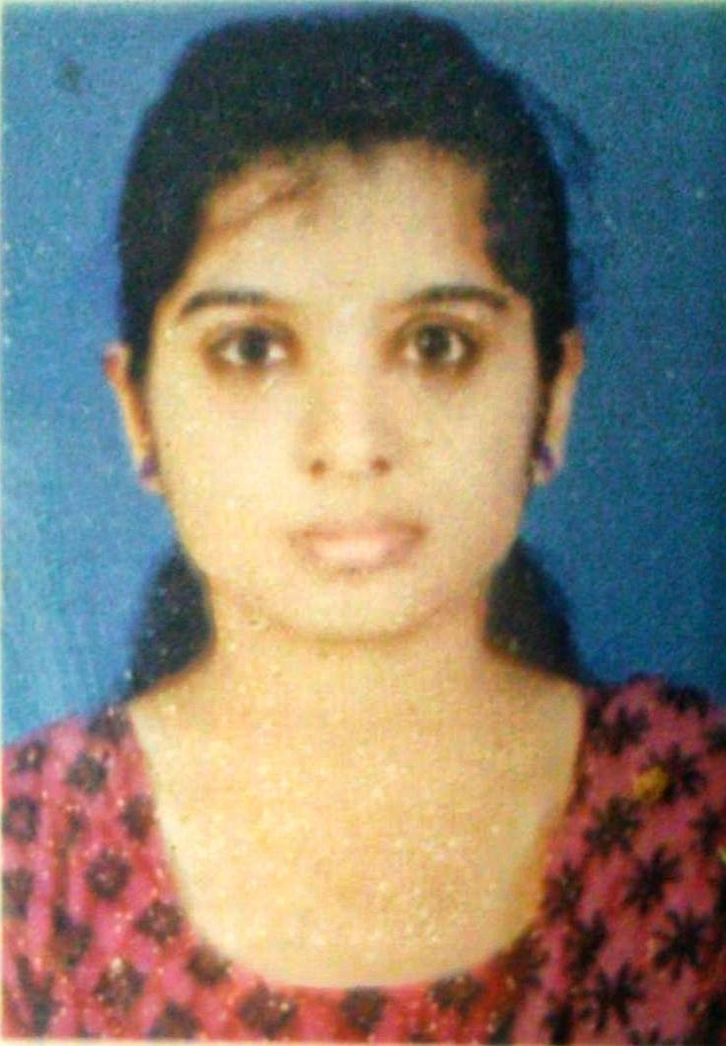

Date of Birth : 09-10-1996 Sex: Male
Father : Murali Gopalan K
Mother : Shylaja K Nationality : Indian Domicileof : Kerala Marital Status :Single
Hindu
:
Religion
Permanent Address
Sreeshylam, Ramanthali PO, Kannur, Kerala India:-670308
Personal Information
E-Mail: anchitha.karissery@gmail.com
PH: +919446316392
ANCHITHA.K
Profile
I'm a BDS graduate, seeking an opportunity to showcase the acquired knowledge and skills in your reputed organization in order to improve my dental career.
Career Objectives

- To build a long-term career in healthcare, with opportunities for career growth.
- To keep up with cutting-edgetechnologies.
- To use my skills in the best possible way for achieving the goals.
- To solve a problem in an effective manner in a challenging position.
- To learn from experience and develops a valuable asset for the organization.

Education

- Bachelor of Dental Surgery (BDS)
Government Dental College, Pariyaram
Kerala University of Health Sciences

Higher Secondary School
Kendriya Vidyalaya Payyanur, Payyanur
Kendriya Vidyalaya Sangathan
Percentage: 88

Secondary School
Kendriya Vidyalaya Payyanur , Payyanur

Kendriya Vidyalaya Sangathan

Grade points:9.4

PROFESSIONAL EXPERIENCES

BACHELOR OF DENTAL SURGERY
    - Bachelor of dental surgery In Government Dental college Kannur – July 2021 -Present
    - One year intership in Government Dental College Kannur. September2022- present.

- 15 days certified work experience in Department of Emergency medicine at Government medical college Kannur.
- AHA certified BLS certification

Linguistic proficiency
English Malayalam
Hindi
Job description

          - Provide general dental care by cleaning teeth and filling cavities
          - Repair and remove problematic or chipped teeth
          - Correct teeth alignment or placement by installing braces
          - Protect teeth by using sealants or using whitening treatments
          - Recommend patients to dental specialists as needed for recommended procedures
          - Instruct patients about best practices in oral health, and recommend the best brushes and toothpaste for their needs
          - Create models of crowns and dentures by taking measurements and making models
          - Review x-ray images captured in the office to determine the health of the teeth and potential areas of concern

Technical skills

    - Excellent communicationskills.
    - Computerskills
    - Self and groupmotivation.
    - Problem-solving capability.
    - The desire to learn and adapt.
Accomplishments & Interests

    - Interested in drawing
    - Interested in photography
    - Love to travel
Declaration

I hereby declare that the above-mentioned information is correct to the best of my knowledge and belief

Date: 08/09/2022 Yours Faithfully Place: Kannur. ANCHITHA.K

