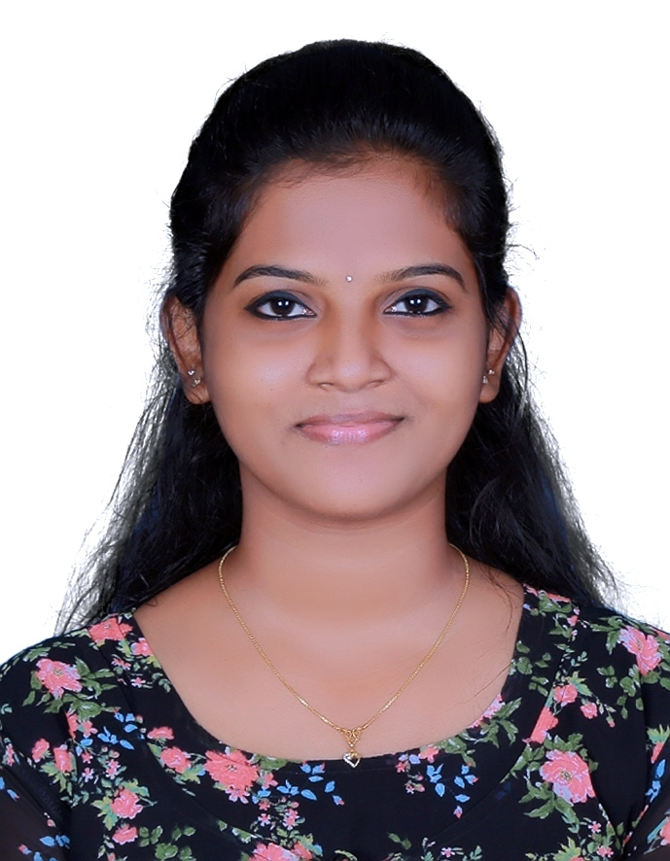
RESUME
SONA JOSHY
UKKEN HOUSE
POLICE STATION ROAD ,CHALKUDY
E-mai: sonajoshy007@gmail.com
Mobile:9745058404

CAREER OBJECTIVE

To achieve excellence in the field of Nursing and to attain a challenging career where I can contribute to the best of my knowledge and talents for the benefits of the hospital as well as for improving up on my merits.

PERSONAL DEATAILS
Name : Sona Joshy
Father name: Joshy Antony
Date of Birth : 12/02/2000
Sex ; female
Religion : Christian (RC)
Nationality : Indian
Marital status : Unmarried

EDUCATIONAL QUALIFICATION
Sl. No | University/board | Name of school | Year of passing
Higher Secondary  Course (science) | Board of Higher  Secondary Examination  (Kerala) | UNION HSS ANNANNAD | 2017
SSLC | Kerala State Board of  Public Examination | - H. C. G. HSS CHALKUDY | 2015

PROFESSONAL QUALIFICATION

Qualification | Name of institution | Name of board  And University | Year of Passing
B.sc Nursing | Snehodaya College Of Nursing Vallakunnu Irinjalakkuda | Board of Kerala Nursing Council  Kerala university of health Sciences | 2022

LANGUAGES KNOWN
• Read: English, Malayalam
• Write: English, Malayalam
• Speak: English, Malayalam

INTEREST/SKILLS
• Therapeutic applications and administration of good analytical skill in assessing condition and implementing appropriate intervention.
• Remain calm & professional throughout critical incidence
• Develop rapport with clients, family, staff & physicians
• Relate well to the people from variety of cultures.
• Basic computer skill & with the working knowledge of the internet.
• Hardworking & fast learner
• Willing to extend knowledge in the field of nursing

SKILLED IN

• Cannulization

• Catheterization

• Nasogastric Tube Feeding

• CPR

• Defibrillation

• Wound Dressing

• Oxygen Administration

• Administration of Oral Medications & Injections

• Monitoring Vital Signs

• Transfusion of Intra venous fluids

• Giving Enemas

• Blood Transfusion

• Collection of specimens handled equipment’s

• Pulse Oximeter

• Cardiac Monitoring machine

• Infusion pump

• Suction machine

• Sphygmomanometer

• Glucometer

• Stethoscope

• Thermometer

• Nebulizer

• Phototherapy Machine

• CTG Machine

• Steam Inhalation

Reference

Prof. Sr. JAISY CSS

Principal

Snehodaya college of Nursing

Vallakkunnu

Irinjalakuda, Thrissur

DECLARATION

I hereby declare that the above furnished details are true and correct to the best of my knowledge and belief.

Place : Chalakudy

Date : SONA JOSHY

