CURRICULUM VITAE
PERSONAL INFORMATION
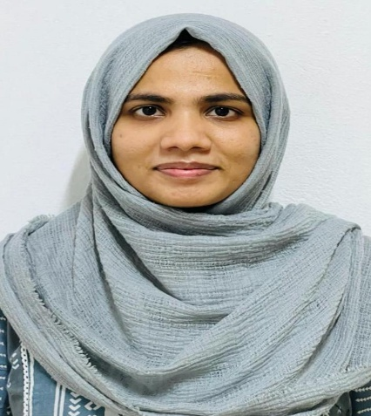

Name: Dr ADHILA
Age/Gender: 25/F
Date of Birth: 15-11-1996
Father’s Name: ABDUL BASHEER MAYYERI
Mother’s Name: KHADEEJA TA
Place: VALAVANNUR[MALAPPURAM]
PermanentAddress: MAYYERIHOUSE,
VARAMBANALA
VALAVANNUR(PO) TIRUR
MALAPPURAM 676551
Contact Number: 6238168361
E-Mail: adhilamayyeri@gmail.com
Marital Status: married
Languages Known: English, Malayalam and Hindi

CAREER OBJECTIVE
Hardworking and Job oriented medical professional seeking a career, where my potential for work and medical skills would be gainfully utilized and be a part of an organization where I can give and learn more of my skills .

SKILLS AND QUALITIES
⚫ Self confident
⚫ Hard working
⚫ Patient centred Care
⚫ Good verbal and communication skills
⚫ Good level of patience and responsibility
⚫ Good Listener

EXPERIENCES
⚫ Attended Medical Camps in Rural Areas
⚫ Attended Workshops in BLS& ACLS
⚫ Attended Fever clinic and have done Multiple swab collections

ACADEMIC DETAILS
⚫ Bachelor of Medicine and Bachelor of Surgery (MBBS)

KMCT Medical College, Kozhikode (2016 Batch)
Under Kerala University of Health Sciences (KUHS)
Year of Completion of Rotatory Internship –
TCMC Permanent Registration to be done
⚫ HIGHER SECONDARY EDUCATION
12th Passed from MSMHSS kallingalparamb , Tirur Malappuram in 2015

⚫ SECONDARYEDUCATION
10th (CBSE) Passed from MES Central School, Tirur Malappuram in 2013
DECLARATION
I hereby declare that the above information given by me is true to the best of my knowledge and belief. I am in possession of all the original certificates and i will produce the same on demand.
Thanking you
Dr Adhila

