DRISHYA T

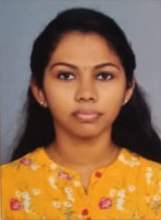
Contact no:9207958346

E Mail: kndrishyat@gmail.com

Skills:
Professional/technical skills
Skilled in handling spectroscopy, chromatography, extraction
Computer skills
Ms powerpoint , Ms word, Ms excel
Languages known
Malayalam, English, Hindi

Career Objective: To utilize my technical skills and provide a professional service to customers by applying and honing my knowledge and working in a challenging and motivating working environment.
Experience in internship
Position: Pharmacy assistant
Worked as a trainee pharmacist in a medical store
Learned to interact with patients
Duration:150hrs

Qualifying examination | University/Board | Year of passing | Grade/score
B Pharm | Amrita Vishwa Vidyapeetham, Kochi | 2022 | 7.3
12th  Higher Secondary Examination | Board of higher secondary examination, Kerala | 2018 | 83%
10th  Secondary school leaving certificate | Board of public examination, Kerala | 2016 | 80%
Educational Qualifications:
Workshops or seminars attended:
Organizer: Pharmacy practice forum, IPA Kerala state branch
Topic: NEW HORIZONS OF PHARMACY PRACTICE
Speaker: Dr SONY PAULOSE
Awards and achievements:
District level winner in Thiruvathirakali (2013)
Participated in sub district level group dance, still modelling
Projects
AIM: To compare various citrus fruit juices for its effect on metabolic disorders using invitro study.
Performed fructose estimation, glucose estimation , ascorbic acid estimation, anti hypertensive activity (ACE inhibition), and antidiabetic acivity (alpha glycosidase inhibition), in citrus fruit juices.
Personal attributes:
Good in interactions
Team work and collaboration
Leadership
Strong work ethics
Critical thinking and problem solving
Personal details:
Contact address: Kuzhikkattukunnel(H), Perumpilly P O, Mulanthuruthy, Ernakulam
Nationality: Indian
Mother tongue: Malayalam
Passport Number: V9512855 Validity: Till 2032

