RESUME

JOMOL HERMAN
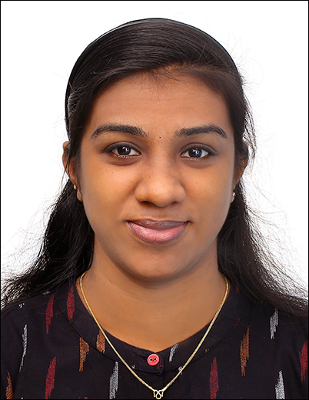
Address : Kanapilly(H), 11/377 INS Dronacharya Road Main Gate Ernakulam Dist.,Kerala,India
DOB : 13.09.2000
Contact : +91 9961993723
E-Mail : jomolachu143@gmail.com

Objectives

Pharmacy Assistant with excellent data entry skills and telephone etiquette details-orientated and focused on accuracy and efficiency. Self - starter with extensive knowledge of medical and medicare procedures

- Expectional patient care and interaction
- Professional telephone etiquette
- Able to maintain good relations and communications withpatients
- Teamwork
- Fastlearning

Personal Information

Name : Jomol Herman
Father’sname : K.C Robin
Religion : Christian
Nationality : Indian
Maritalstatus : Single
Languages

Malayalam(mother tongue),English
Educational Qualification

Course | Name of Institute | Year of Passing | Percentage (%)
BSS DIPLOMA IN PHARMACY ASSISTANT AND COMPUTER APPLICATION  PHARMACY ASSISTANT | Fatima Institution of medical science | 2018-2020 | 98%
SSLC | Fatima Girls Higher secondary school, Fort kochi | 2016 | 80%
Experience

Fatima Hospital,perumpadappu, Cochin

Duration: 2 Year ( Still working at pharmacy assistant)

DECLARATION

I hereby declare that all the above information is true. I assure you that if I would have given a chance I will execute my work to the fullest satisfaction ofyou.
Place : Fort Kochi Jomol Herman
Date:

