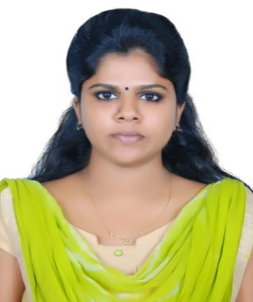
ACHUTHA S KAMAL
Valliyil Thekkathil House
Near Nava Nirman
VazhakkalaThrikkakkara PO,
Ernakulam District
Kerala - India
PIN : 682021
Email:achuthakamal14@gmail.com
Mob: +91 6238456358
Mob : +91 8547881355

Career Objective
“Looking for an opportunity to bring efficiency and expertise to the job in an organization to develop in the best possible way and become motivated.Also I would like to utilize my lively and energetic attitude with great enthusiasm.”

Academic Chronicle
Qualification | Institution | Board/university of study | Year of Completion | Percentage/CGPA
MCA | SCMS School of Technology & Management, Muttom | MG University | 2018  (december) | First class  (70%)
BCA | Amrita School of Arts &Science,Kochi | Amrita VishwaVidyapeetham | 2015  (may) | 65%
12th | Nava Nirman Public School,Kochi | Central Board of Secondary Education | 2012  (march) | 64%
10th | KendriyaVidyalayaCochin Port Trust | Central Board of Secondary Education | 2010  (march) | 74%

Academic Projects
- “PaperBoy” app(main project during graduation)
- “Puzzle” game(mini project during graduation)
- “Hostel mangement System”(mini project during post-graduation)
- “Civil supplies management system”(mini project)
- “Kudumbasree management system”(main project)

Extra-Curricular Achievements

- Took part in KMRL(KOCHI METRO RAIL LIMITED)Auto-feeder survey2017.
- Won prizes for various dance competitions.
- Won Southern Regional level prize for Volleyball tournament.
- Won prizes for Badminton.

Technical Skills

- C programming
- C++
- JAVA
- C#
- Python
- PHP

Key Skills/Strengths
- Creative, Initiative and Innovative.
- stress and time management ability

Hobbies
- Dancing.
- Paper arts.
- Cooking.
- Travelling

Personal Vitae
- Date of Birth :14th October 1994
- Marital Status :YES
- Spouse :Soul S
- Father’s Name :Kamalasanan K
- Mother’s Name : Sudha S
- Proficiency in Languages :Malayalam, English

Experience

Company : ANON TRENDS Animation Company (April 2019-August2019)
Designation : Web and Production Coordinator

Declaration

I hereby declare that the above written particulars are true to the best of my knowledge and belief.

Place: Kochi ACHUTHA S KAMAL

