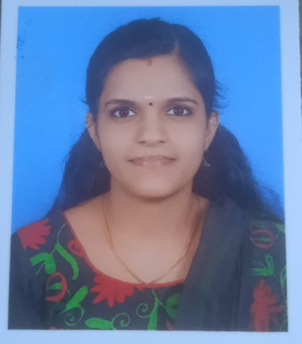

To achieve a challenging position in a professional organization through self - improvement by excelling in all responsibilities with sincere hard work, dedication & commitment. To work towards the development of the organization & grow with it.

**CAREER ABRIDGEMENT**

**KEY SKILLS**

**Patience**

**Leadership**

**Interpersonal Skills**

**Decision Making**

**Respectfulness**

**Self-evaluation**

**Confidence**

**Critical thinking**

**Emotional intelligence**

NEETHU MOHAN

**EMPLOYMENT CHRONICLE**

**ACCOUNTANT |2020**

**KMK HOSPITAL PARAVUR**

**ACCOUNTANT |1 year**

**ORANGES BOUTIQUE, KALOOR**

**ACCOUNTANT |1.5 year**

**MATHA DISTRIBUTORS, MAMANGALAM**

**ACCOUNTANT|5 YEAR**

**PASSES POWERS, PERUMBAVOOR**

**ACCOUNTS TRAINEE |1 years**

**SALE TAX CONSULTANT**

**KEY RESPONSIBILITIES**

* Compiling, analyzing, and reporting financial data
* Creating periodic reports, such as balance sheets, profit & loss statements, etc**.**
* Maintaining accurate financial records.
* Performing audits and resolving discrepancies.
* Computing taxes.
* Keeping informed about current legislation relating to finance and accounting.
* maintain day to day accounts and reporting corporate office on time to time.
* Ensuring the accuracy of financial documents, as well as their compliance with relevant laws and regulations
* Evaluating financial operations to recommend best practices, identify issues and strategize solutions, and help organizations run efficiently.
* Offering guidance on cost reduction, revenue enhancement, and profit maximization.
* Conducting forecasting and risk analysis assessments.

CONTACT

Receiver

+91 9645133595

Neethum27@gmail.com

Kerala, India

Envelope

Marker

ACADEMIC CREDENTIALS

**B COM** |2009

* M G University

**HIGHER SECONDARY** |2006

* Board of Higher Secondary Examination, Kerala, India

**SSLC** | 2004

* Board of Public Examination,

Kerala, India



**MS Office**

**Sap**

**Tally PRIME**

**Basic Operations**

**Internet & Email**

COMMUNICATION - Interpersonal skills – verbal, problem solving and listening skills in any administrative role.

SERVICE - Having a client focused approach Skills include Patience, Attentiveness and a positive language.

ORGANIZATION - Helping others, organizing a to‐do list. Prioritizing tasks by the deadline for improving time -management.

MANAGEMENT- Management skills to direct others and review others performance.

**PERSONAL STRENGTHS**

COMPUTER PROFICIENCY

LANGUAGES KNOWN

* English
* Malayalam (Mother Tongue)

PERSONAL INTEREST

**PERSONAL DOSSIER**

Headphones

Gender : Female

Date of Birth :10.05.1988

Nationality : Indian

Marital Status : married

Permanent Address : KUTTIKKATTU HOUSE, PULLAMKULAM, N.PARAVUR

**Listening Music**

**Travelling**

**Reading**

Airplane

Closed book

REFERENCE

* Available upon request

**DECLARATION**

I hereby declare that the above-mentioned information is true and I bear the responsibility for the correctness of the above-mentioned particulars

**NEETHU MOHAN**

**SUSANTH.K.S**