CURRICULUM VITAE
Name: Dr. Aanshy Sanil Baskar 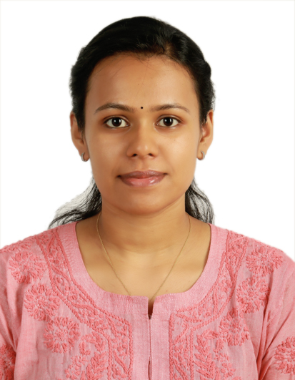
Permanent Registration Number: 77538 (Under Travancore - Cochin Council of Modern Medical Science)
Contact ID: aanshysanil@gmail.com
Contact number : 8281100221
Date of birth: 30/01/1996
Languages spoken: Malayalam, English

CAREER OBJECTIVE :
Looking for position of Junior Doctor duty to learn new skills and to gain more knowledge to enhance my personal growth as an excellent medical practitioner.

EDUCATIONAL DETAILS :
- Bachelor of Medicine and Bachelor of surgery (MBBS) from Al Azhar Medical College, Thodupuzha (2014-2020) under Kerala University of Health Sciences
- School Education from Abhu Dhabi Indian School, Abhu Dhabi

Work Experience:
(15/05/2021 - 29/10/2021)
COVID ICU, General Hospital, Ernakulam

MBBS TRAINING :
Underwent House Surgency from:
General Hospital, Ernakulam (10 months)
and Al Azhar Medical College, Thodupuzha in Community Medicine (2 months)

Key Skills:
# Assisting the senior doctor in checking the patients.
# Periodically meeting the patients and observing their improvements and making reports.
# Critical care documentation along with discharge protocol, end of life care and management, scoring of critical care.
# Application of commonly used sedation and analgesic and muscle relaxant (propofol, midazolam, lorazepam, dexmedetomidine, tramadol, morphine, vecuronium) and their dosing.
# Procedure -- Central venous catheter, dialysis port insertion, intubation, inserting Ryle's tube, assisted bronchoscopy and lumbar puncture.
# Mechanical ventilator management and weaning of patients.
# Suturing open wounds.
# Pain management, infection control, electrolyte management.
# In case of emergency, giving the basic treatment to the patients.
# Helping other medical staff in performing their duties.
STRENGTHS :
- Excellent theoretical knowledge.
- Excellent communication skills.
- Good knowledge of clinical practices and protocols.
- Ability to handle different patients in critical situations.
- Flexible and adaptable.
- Extremely motivated towards career.
- Quick Learner.

Date: 28/05/2022
Place: Nattika, Thrissur

