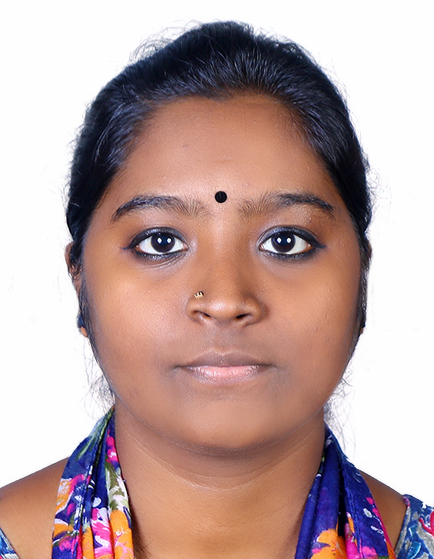
BIODATA
LAKSHMI JAYAN
Machampilly (H)
Elavoor P O , Elavoor
Angamaly,pin:683572
Ernakulam( district)
Kerala
Phone:6282585804
Email: suryalakshmilachu@gmail.com

CAREER OBJECTIVE:
- Looking for a long-term association with career oriented organization where team work, honest and hardwork are acknowledged and conclusive work culture provided.

PERSONAL PROFILE:
Name : Lakshmi Jayan
Age : 23
Sex : FEMALE
Date of birth : 20/11/1998
Father’s name : Jayan M.K.
Mother’s name : Sujatha M.K.
Religion : Hindu
District : Ernakulam
Nationality : Indian
Marital status : Unmarried
Contact number : +916282585804
Hobbies : Listening music, craft making (terracotta and paper jewellery), clay
Modeling ,Newspaper reading journals and magazines
Languages known :Malayalam,English,Hindi,Urdu

EDUCATUIONAL QUALIFICATIONS:
EXAM PASSED | INSTITUTION/UNIVERSITY | YEAR | BOARD | MARK AWARDED
BSc Nursing | St. James college of Nursing, Chalakudy,Thrissur dist | 2016-2021 | KERALA UNIVERSITY OF HEALTH AND SCIENCES | 1st year-60%  2nd year-64.38%  3rd year-65.76%  4th year-59.42%
HIGHER SECONDARY | Union Higher Secondary School ,Mambra,Thrissur dist | 2014-2016 | State Board of Kerala | 71.5%
SSLC | Union Higher Secondary School ,Mambra,Thrissur dist | 2013-2014 | Board of KSE, Kerala | 83%

ADDITIONAL CERTIFICATION:
COURSE | DATE
NEW BORN SEPSIS | 09/12/2020
EMERGENCY OBSTETRICS AND NEW BORN CARE | 08/12/2020
CASE MANAGEMENT OF CHILDHOOD ILLNESS | 06/12/2020
IMMUNIZATION ESSENTIALS | 05/12/2020
ANTENATAL CARE | 04/12/2020
COVID-19 CHALLENGES IN NURSING PRACTICE | 19/09/2020

COMPUTER SKILLS:
- Internet and Email
- Microsoft office word
- Microsoft office excel
- Microsoft office spreadsheet
- Microsoft office power point
LANGUAGES KNOWN:
- Speak-Malayalam,English,Hindhi,Urdu,Tamil
- Read- Malayalam,English,Hindhi,Urdu
- Write- Malayalam,English ,Hindhi,Urdu
STRENGTHS:
- Self confident,self-disciplined and delligent person.
- Human relation attitude,honesty, positive thinking with optimistic and straight forward
- Leadership,foresight skill
- Digital nature and practical approach towards problem
AREAS OF EXPERIENCES:
- Excellent in communication skills
- Good presentation skills
- Good leadership skills
- Determined, Dedicated, Disciplined
- Confident in quality of work
NATURE OF DUTIES:
- Admission and discharge procedures
- Taking and giving charge
- Patient care plans
- Patient education and health education
- Accident ant trauma care
- Emergency care
- Isolation precautions and take care of pandemic situations
- Wound and skin care
- Administration of drugs, IV cannulations, infusions and blood and blood product administrations
- Invasive procedures like insertion of Foley’s catheter, Ryle’s tube etc..
- Step up and take care of CVP line, infusion pumps, care of central lines
- Assistance for intubation
- Care of patients during emergency procedures like intubation ,CPR etc
- Death care(PACKING),vital signs checking and recording, RT feeding etc.
- Antenatal and postnatal examinations, assistance in normal delivery, emergency and immediate newborn care
- Community health nursing-home visit, family care plan, National immunization programme (2019), field visit etc.

DECLARATION
In the view of the above ,I request you to be kind enough to give an opportunity to serve your esteemed organization for which act of kindness, I shall be very grateful to you.
I here by declare that all the information furnished above is true to the best of my knowledge.
Place : Ankamaly
Date: (LAKSHMI JAYAN)

