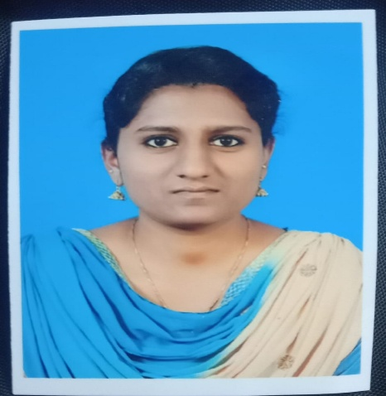
RESUME
Name : Anitha J
Contact number : 9791826063
E-mail : anithaestherj@gmail.com
PERSONAL DETAILS
Date of birth : 15/2/1997
Nationality : Indian
Gender : Female
Marital status : Unmarried
Religion : Christian
Height : 153 cm
Weight : 55kg
BMI : 23.5
Present address : Vijaya Jebadass
Madha kottai
Oormetchikulam
Samayanallur
Madurai, Tamil nadu, India
Pin code: 625 402
Permanent address : Vijaya Jebadass
30/E pillayar kovil street
Oormetchikulam
Samayanallur
Madurai, Tamil nadu, India
Pin code: 625 402
PASS PORT DETAILS
Passport no : T2164255
Place of Issue : Madurai
Date of Issue : 22/08/2019
Date of Expiry : 21/08/2029
EDUATIONAL DETAILS
College/ University Attended : CSI Jeyaraj Annapackiam College of Nursing /
Dr.MGR University, Chennai
Qualification : Bsc Nursing
Graduation Date : 20/09/2018
REGISTRATION DETAILS
Registration Authority : Karnataka State Nursing Council
Registration No : RR TMN 2020 8838 KAR
Registration Date : 10/06/2020
Validity Date : 08/01/2024
EXPERIENE SUMMARY
Previous experience -1
Name Of the hospital : Christian Mission Hospital
Bed Capacity : 150
Position : Staff Nurse
Clinical Area : Medical And Surgical Ward
Duration : 01/10/2018 to 30/09/2019
Previous experience -2
Name of the hospital : St. Johns Medical College and Hospital
Bed Capacity : 1300
Position : Staff Nurse
Clinical Area : Male Medicine Ward
Duration : 03/10/2019 to 13/04/2021
Present experience
Name of the hospital : Apollo Specialty Hospitals
Bed Capacity : 250
Position : Staff Nurse
Clinical Area : ICU
Duration : 20/4/2021 to till date
DECELERATION
I here by declare that all the details furnished above are true to the best of my knowledge. I look Forward to work in your institution and I am happy to show my professional skills.
Your sincerely,
Anitha J

