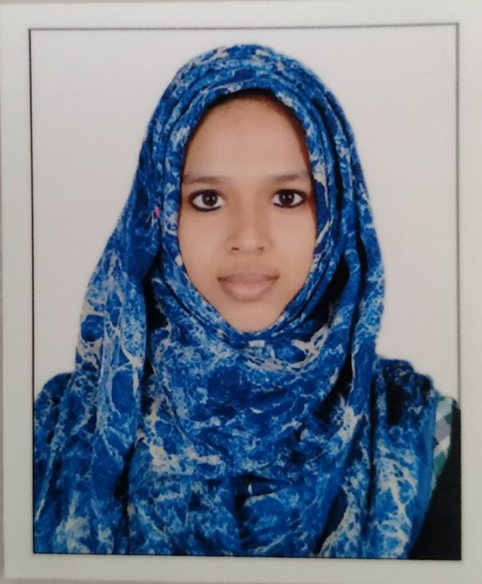
CURRICULUM VITAE
MUHSINA P. M
D/O Mujeeb Rahman
Puthiyaveettil (H)
Kaipamangalam (P.O)
Kalamuri, Thrissur Dt.
Kerala State. 680681
PERSONAL PROFILE
Date of Birth : 26/04/1999
Religion : Islam
Caste : Muslim
Sex : Female
Nationality : Indian
Marital status : Single
Languages Known : Malayalam, English, Hindi
Contact Number : 9207413309
Email ID : muhsinapm2604@gmail.com
CAREER OBJECTIVE
Secure a responsible career opportunity to fully utilize my training and skills, while making a significant contribution to the success of the company.
JOB RESPONSIBILITY
- Planning and evaluating department activities.
- Maintenance employees by recruiting, selecting, orienting, and training.
- Ensure a safe and secure work environment.
- Contributes to team effort by accomplishing related results as needed.
EDUCATIONAL QUALIFICATION
QUALIFICATION | YEAR OF PASSING | BOARD/UNIVERSITY | PERCENTAGE
SSLC | 2015 | CBSE | 98
PLUS TWO  BIO SCIENCE | 2017 | KERALA STATE BOARD | 85.5
DEGREE  B. COM | 2020 | CALICUT UNIVERSITY | 62.3

PROFESSIONAL QUALIFICATION
- Pursuing MBA from MG University
ADDITIONAL QUALIFICATION
- Diploma in International corporate Accounts and Management
EXPERIENCE
- 6 Months experience as Accounts Assistant in Total Tax Solutions.
TECHNICAL SKILLS AND ACTIVITIES
- Computer literate with knowledge of Microsoft Office Package (Ms Word, Excel, Access.
- SAP FI and CO
- Highly motivated with good management and interpersonal skills.
- Ability to perform under pressure and maintain social, ethical and organizational norms in job related activities.
REFERENCE
MES AIMAT MARAMPALLY
ALUVA
(HOD)
DECLARATION
I hereby declare that all the above details are true and correct to the best of my knowledge and belief. I promise you that I will be a dynamic personality who is very truthful and loyal to contribute to the organisation’s goal.
Date : 5/7/2021
Place : Kodungallur Name: Muhsina P. M

