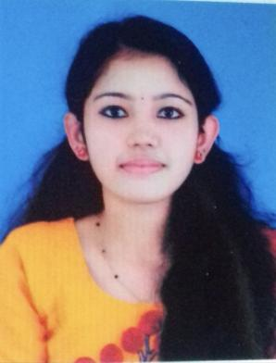
Sushama Nivas
Shiribagilu P.O.
MAITHILY KS Periyadukka
Mob: 7561860816 ,7994144134 Kasaragod
E-Mail: maithilyshaji25@gmail.com Kerala – 671124
CAREER OBJECTIVE
To build carrier in a growing organization, where I can get the opportunities to prove my abilities by accepting challenges, fulfilling the organizational goal and climb the carrier ladder through continuous learning and commitment.
EDUCATIONAL QUALIFICATIONS
- Post Graduation [MSc. Food Science,Nutrition and Dietitics]
St. Aloysius Autonomous Mangaluru, Karnataka - 2021
- Graduation [B.Sc. Microbiology]
St Pius Xth College,Rajapuram,Kasaragod, Kerala – 2019
- Intermediate (12th Science)
BEMHSS Kasaragod, Kerala – 2016
- Matriculation (10th SSLC)
Jai Matha English Medium Senior Secondary School, Kerala – 2014

Computer Knowledge
- MS Office
CERTIFICATION
- SPORTS NUTRITION
INDUSTRIAL VISIT
- Nandini,Mangalore, Karnataka

ACADEMIC PROJECT
- Screening and characterization of Fluorescent psueodomonas from mango rhizosphere
INTERNSHIP
- Successfully completed 2 months Internship in the department of Clinical Nutrition & Dietitics at Aster MIMS Calicut, Kerala
- Successfully completed 6 months training under Dietitian at Aster MIMS,Kannur
PERSONAL DETAILS
Date of Birth : 16/02/1998
Father’s Name : Shaji KR
Sex : Female
Nationality : Indian
Religion & Caste : Hindu, Viswakarma
Marital status : Single
Languages known : English, Malayalam, Hindi
Permanent Address : Sushama Nivas
Shiribagilu P.O.
Periyadukka
Kasaragod
Kerala – 671124
REFERENCE

- Meghna C M
Lecturer
Dept. of Food Science & Quality Control
St. Aloysius College Mangaluru, Karnataka
Mob: +91 9605465994
DECLARATION
I, hereby declare that all the above statements are true and correct to the best of my knowledge and belief.
Place: Periyadukka
Date: 19/04/2022 MAITHILY KS

