CURRICULAM VITAE
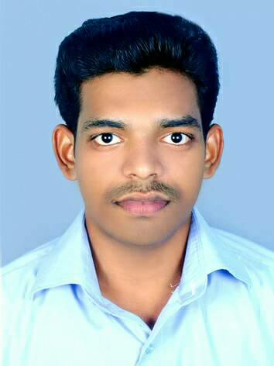
JINESH MATHEW

PARIYARATH
KANAKAMALA P.O.
KANAKAMALA, CHALAKKUDY
THRISSUR (Dist)
KERALA, INDIA
Pin –680689
(Mob. No) +91- 9048007811, 8893006360
Mail id: www.jineshmathew@gmail.com

OBJECTIVE

To become a successful professional and to work in an innovative and competitive environment as a contributing member with commitment and dedication. Seeking a reputed company where I will get an entry level training to build a successful career by utilizing my knowledge.

ACADEMIC QUALIFICATION

- Secondary School Leaving Certificate Govt. of Kerala
- Higher Secondary School Leaving Certificate Govt. of Kerala
- Degree in Commerce

COMPUTER KNOWLEDGE

- TALLY ERP.9

- MS OFFICE

PERSONAL DETAILS

Father’s Name : P.M. Mathew
Gender : Male
DOB : 10/03/1995
Nationality : Indian
Religion : Christian
Language Known : Malayalam, English
Marital Status : Married
Passport Number : R5234858

DRIVING LICENSE DETAILS – (34/4868/2016)

- M/C WITH GEAR
- LMV

EXPERIENCE DETAILS

- OFFICE STAFF - 15 MONTHS AT KRIPA ASSOCIATES (Finance Collection Agency of Bussan Auto Finance India Pvt Ltd).
- ACCOUNTANT - 6 MONTHS AT ARTSRA FASHIONS KOTTAYAM
- ACCOUNTANT ASSISTANT - 1 YEAR AT THANKAMFUELS, CHERTHALA.
- CASHIER CUM BILLING STAFF - 1 YEAR EXPERIENCE at ASWATHY MART, CHERTHALA.
- CASHIER CUM BILLING EXECUTIVE - BELIEVERS CHURCH MEDICAL COLLEGE HOSPITAL THIRUVALLA ( From 2019 OCTOBER 15 - STILL WORKING )

DECLARATION

I hereby declare that all the statements given in the above application is true and correct to the best my knowledge and belief.

Date : 01/04/2022 JINESH MATHEW
Place : CHALAKKUDY

