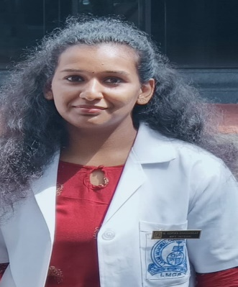
M GOPIKA SIVASANKARAN
Physiotherapist
Zone 43, street 990, building no: 73, Al Hilal, Doha, Qatar
gopikagopu188@gmail.com
+974 66508459, +974 31241285
18/02/1997

OBJECTIVE
To contribute in effective health care treatment of patients, improved lifestyle by implementation of relevant physiotherapy techniques and interventions. Passionate for excellence and constantly looking forward to advance my knowledge and professional experience both in academics and as well as clinical practice. Working in a challenging field which will make full use of my abilities, developing both personal and interpersonal skills, along with sincere contribution to the organizations growth and goals.

SKILLS
- Experienced in using different rehabilitation techniques and equipment.
- Ability to work with patients with a variety of diagnoses and needs.
- Rehabilitation of different musculoskeletal diseases and injuries
- Have experience in dealing with pediatric problems especially CP.
- Chest physiotherapy skills.
- Experienced in dealing with neurological, geriatric, cardiac, pre and post-surgery cases.
- Knowledge of rehabilitation given for ICU patients.
- Having a caring attitude when supporting patients during therapy sessions
- Showing tolerance and patience when dealing with patients, relatives and careers
- Good ability to demonstrate different methods, actions and positions
- Quick learner, Goal oriented and good problem solver
- Self-motivated and good motivator.
- Identify potential problems and determine the best solutions
- Good communication, and interpersonal skills
- Superb organizational and time management skills
- Flexibility to work weekends on rotational basis
- Ready to work both morning and evening shift according to the hospital needs.
- Certified Kinesiotaping and dry needling
- Qatar prometric passed
- Life member of “Indian association of physiotherapist”.

EXPERIENCE
Dr James Sebastian's clinic 05/11/2021-05/02/2022
Physiotherapist
I have a 3 months experience in Dr James Sebastian's clinic under
Dr James Sebastian M.B.B.S, MD, FAGM
The duties included was *Taking proper assessment of the patients *accurately diagnosing the patients *Developing treatment plan, short term and long term treatment for the patients *providing best treatment *Keeping a record of patients prognosis *Teaching home exercise.

EDUCATION
Rajiv Gandhi University of health sciences 2016-2021
Bachelor in Physiotherapy
Grades - 65.82%
CBSE board (Saraswathi Vidhyanikethan Higher secondary school) 2015-2016
12th
Grades - 73%
CBSE board (Greets Public School) 2013-2014
10th
Grades – 83%

ACHIEVEMENTS AND AWARDS
*IAP(Indian Association of Physiotherapy) conference attended in Bangalore.
*Volunteered Confluence 2019.
*Participated in Adrenaline
*Achieved 2nd rank in neuro-physiotherapy university examination held by RGUHS.

*Undergone training on mechanical, radiological differential diagnosis and it's dry needling and myokinetic therapy in musculoskeletal disorders and kinesiotaping.

*Done a project on “Effectiveness of neck flexors and extensors muscle strengthening exercises in reducing pain, disability and improving cervical range of motion in migraine patients” and is under evaluation for publication in IAP journal.

INTERESTS
I enjoy singing and dancing because of which I enjoy taking part in cultural competition and conferences which has pushed me out of my comfort zone, allowed me to meet new people and boosted my confidence.

LANGUAGE
ENGLISH
MALAYALAM
TAMIL
HINDI

