ABHISHAK T.S
REGISTERED NURSE
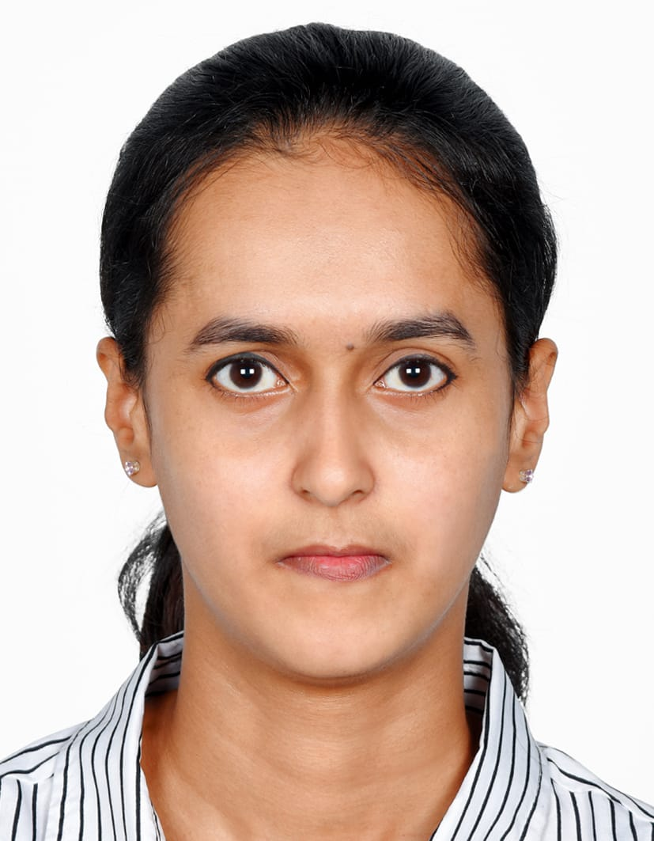  OBJECTIVE  An experienced and fully qualified registered nurse with over 1 year and 4 months of experience of working in busy hospital environments in private sector. Able to work on their own initiative or in support of other healthcare professionals. Whilst ensuring that at all times patient care procedures and practices are adhered to.Experience of looking after patients with various illnesses from chronic conditions. I am currently looking for a staff nurse position in a suitable hospital .  PERSONAL PROFILE  NAME : ABHISHAK T.S  FATHER’S NAME : SONY T.M  D.O.B : 03-03-1998  SEX : FEMALE  RELIGION : CHRISTIAN  NATIONALITY : INDIAN  MARITAL STATUS : SINGLE  LANGUAGE : MALAYALAM, ENGLISH, HINDI, KANNADA TAMIL  ADDRES  THEKKEDATH HOUSE  KUNNUMMAL LINK ROAD  VADUTHALA P.O  COCHIN 682023  ERNAKULAM  KERALA,INDIA  CONTACT  PH NO : 8891863217  EMAIL:  Abhishak.sony03@gmail.com |  | PROFESSIONAL QUALIFICATION  QUALIFICATION INSTITUTION UNIVERSITY YEAR & % (2015-2019)  BSc Nursing - S Institute of nursing science Davangere R G U H S 1st year - 59% 2nd year - 57% 3rd year - 67% 4th year - 64%  ACADEMIC QUALIFICATION  QUALIFICATION INSTITUTION BOARD YEAR  10th St.Antony’s H.S.S Kacheripady Ernakulam S.S.L.C 2013  Plus two St.Antony’s H.S.S Kacheripady Ernakulam Kerala board of higher secondary examination 2015  EXPERIENCE  APOLLO HOSPITAL {22-07-2020 TO 04-12-2021} BANGALORE  STAFF NURSE  B.S.C {Nursing} with over 1year and 4 months of experience in gynecologic and obstetrics , paediatric and neonatal ward.Record maintenance,quality management, reporting and documentation and staff management.In-depth understanding of pain and wound management Hans-on experience in carrying out various nursing procedures like I V Canulation, blood transfusion and dressing.Review medications and treatment of patients indicated by their general health conditions and response to treatment  DECLARATION  I hereby declare that the above information furnished by me is true correct & complete to the best of my knowledge and belief. I would be glad to provide any further details if required.  Place: Ernakulam  ABHISHAK T.S

`

