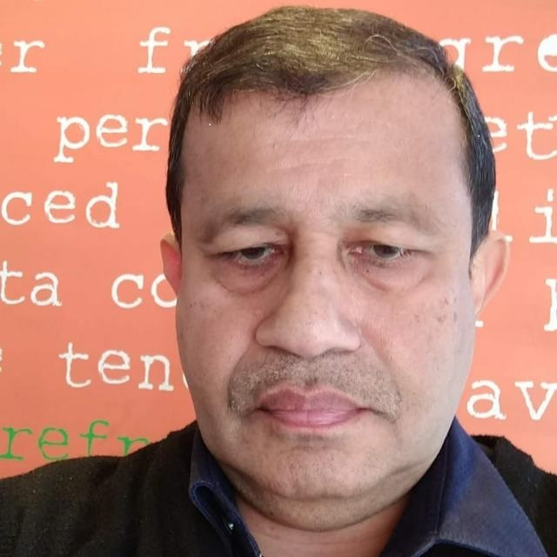

APPLICATION FOR THE POST OF ANAESTHESIOLOGIST

CURRICULUM VITAE

NAME :DR.JACOB AMBOOKEN ITTIYERA

AGE :61 YEARS

DATE OF BIRTH :26/5/1960

SEX :MALE

RELIGION :CHRISTIAN,ROMAN CATHOLIC

NATIONALITY :INDIAN

MARITAL STATUS :MARRIED,2 CHILDREN

PERMANENT ADDRESS :AMBOOKEN HOUSE

BUNGLAW,34/626 D

PADIVATTOM
PALARIVATTOM
ERNAKULAM 682024

KERALA
S.INDIA
Contd>>>

TELEPHONE : 00919846560100

MOBILE :00919846560100(INDIA)

E-MAIL :jacobrek@gmail.com

PASSPORT NO ;K2253426

Contd…..

ACADEMIC QUALIFICTIONS

1.M.B.B.S

COLLEGE:CALICUT MEDICAL COLLEGE,INDIA
YEAR OF PASSING:1980

2.D.A(DIPLOMA IN ANAESTHESIA)

COLLEGE:ST.JOHN’S MEDICAL COLLEGE,BANGALORE,INDIA
YEAR OF PASSING:1992

3.M.D ANAESTHESIA

COLLEGE:ST.JOHN’S MEDICAL COLLEGE,BANGALORE,INDIA
YEAR OF PASSING:1996

EXPERIENCE

WORKED AS PROVISIONAL TUTOR IN ANAESTHESIA,
KOTTAYAM MEDICAL COLLEGE,KOTTAYAM,INDIA
FROM 15/6/1988 TO 14/6/1989

WORKED AS PROVISIONAL TUTOR IN ANAESTHESIA,

TRICHUR MEDICAL COLLEGE,TRICHUR,INDIA
FROM1/9/1989 TO 25/8/1990

WORKED AS ADDITIONAL CONSULTANT IN ANAESTHESIA

M.G.D.M HOSPITAL KANGAZHA,KOTTAYAM,INDIA
FROM 13 /4/1992 TO 20/7/1994

4.WORKED AS CONSULTANT ANAESTHESIOLOGIST
P.V.S MEMORIAL HOSPITAL,KOCHI,INDIA
FROM14/10/1996 TO 13/8/1999

5.WORKED AS ANAESTHESIOLOGIST

AHALIA HOSPITAL,ABUDHABI
FROM 30/8/1999 TO 13/10/2000

6.WORKED AS ANAESTHESIOLOGIST-

AL MAFRAQ HOSPITAL ABUDHABI-FROM28/10/2000 TO 30/06/2007

7.WORKED AS SPECIALIST ANAESTHESIOLOGIST/ACTING HEAD
RUWAIS HOSPITAL FROM 15/07/2007 – TO 15/02/2011

8. WORKED AS CONSULTANT ANAESTHETIST AT P.V.S MEMORIAL HOSPITAL ,COCHIN FROM 28/6/2011 TILL 31/03/2014

9 WORKED AS SPECILIST ANAESTHESIOLOGIST AT JAHRA HOSPITAL KUWAIT UNDER M.O.H FROM 15/11/2014 TO 05/11/2020

Contd…..

DETAILS OF EXPERIENCE

TOTAL EXPERINCE IN ANAESTHESIA:26 YEARS
TOTAL ANAESTHETICS GIVEN :APPROX 80,000 CASES

EXPERIENCE IN ANESTHESIA

INDEPENDENTLY ANAESTHETISED
- CASES IN GENERAL SURGERY INCLUDING LAPAROSCOPIC SURGERIES
2. ORTHOPEDIC CASES INCLUDING POLYTRAUMA.
3. CASES IN PLASTIC &RECONSTRUCTIVE SURGERY.
4. CASES IN UROLOGICAL PROCEDURES &SURGERIES
5. CASES FOR ENT & MAXILLOFACIAL SURGERIES
6. CASES IN PAEDITRIC SUGERY
7. CASES IN NEUROSURGERY
8. CASES FOR OBSTETRIC & GYNAECOLOGY

PREOPERATIVE WORKUP FOR SURGICAL PATIENTS

EXPERIENCE IN INTENSIVE CARE

INDEPENDENTLY MANAGED I.C.U CARE FOR
1.HEAD INJURY PATIENTS
2.POLYTRAUMA
3.ACUTE MEDICAL EMERGENCIES
4.PERFORMING VARIOUS INVASIVE AND NONINVASIVE TCHNIQUES IN ICU-ARTERIAL LINES-C.V.LINES
5.TOTAL PARENTERAL NUTRITION
6.ENTERAL NUTRITION
7.POSTOPERATIVE CASES

SPECIAL INTEREST; LABOR EPIDURAL ANALGESIA

RESEARCH WORK DONE

EVALUATED THE EFFECT OF ONDANSETRON A 5-HT3 ANTAGONIST IN POST OP NAUSEA AND VOMITING AND ITS EFFECT ON GATRIC JUICE Ph &VOLUME

Contd………….

LICENSES

- LIFE LONG PERMANENT REGISTRATION FOR M.B.B.S FROM TRAVANCORE –COCHIN MEDICAL COUNCIL ;INDIA DATED 14/01/1988
- LIFE LONG PERMANENT REGISTRATION FOR D.A AND M.D FROM TRAVANCORE-COCHIN MEDICAL COUNCIL;INDIA DATED 04/09/2004

RECENT CONFERENCES ATTENDED/PRESENTED

1. A.C.L.S PROVIDER COURSE-AMERICAN HEART ASSOCIATION BY
TAWAM HOSPITAL-LSTC-01/05/2009 TO 02/05/2009
2. A.T.L.S COURSE –BY INDIAN SOCIETY OF CRITICAL CARE
MEDICINE- ERNAKULAM MEDICAL CENTRE 07/02/2007 TO
08/02/2007
3. PRESENTED PAPERS ON POST OPERATIVE NAUSEA AND
VOMITING AT RUWAIS HOSPITAL ON 16/01/2008
4. ATTENDED MIDDLE EAST ANAESTHESIA CONFERENCE IN
CONNECTION WITH ARAB HEALTH,DUBAI 28/01/2008 TO 29/01/2008

I HEREBY ACKNOWLEDGE THE DATAS GIVEN ABOVE ARE TRUE TO MY BEST
OF KNOWLEDGE;

PALARIVATTOM DR.JACOB AMBOOKEN
08/02/2022

