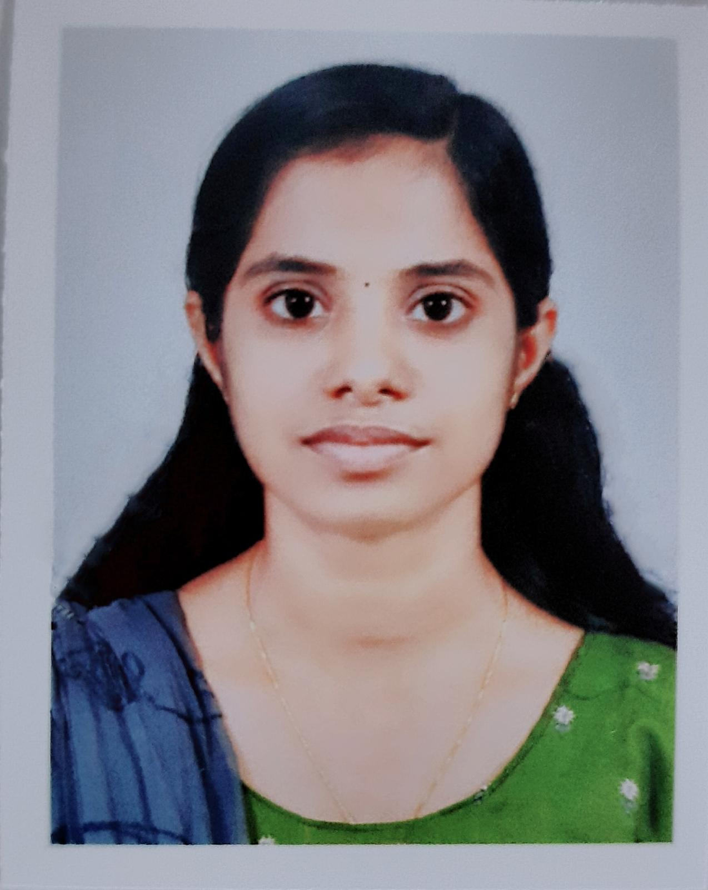
Anju V S
Career Objective
Aim to be associated with the organisation that provides me an opportunity to present my nursing skills and improve my knowledge with latest trends and want to be the part of a team that work dynamically towards the growth of the organisation.
Personal Details
  - Name : Anju V S
  - Address :Vembazhassery(H),Mampuzhakary
Ramankary P.O , Alappuzha
Pin:689595
  - DOB : 30 Nov 1996
  - Gender : Female
  - Marital status : Unmarried
  - Religion : Hindu
  - Nationality : Indian
  - Email id : anju1996vs@gmail.com
  - Phone no : 8590536100

Language Known
English, Malayalam
Skills
- Therapeutic application and implementing appropriate intervention.
- Perform nursing procedures in accordance with the policies and procedures laid down by the institution .
- Relate well to the people from a variety of cultures.
- Develop rapport with the client, family, staff and physicians.
- Willing to extend knowledge in the field of nursing.
- Hardworking and fast learner.
Areas Of Clinical Expertise
- Medical surgical ward
- Obstetrics and Gynaecology ward
- Paediatric ward
- Emergency department
- Oncology and chemotherapy unit
- Psychiatric ward
- Labour room
- Operation theatre
- Intensive care unit
- Medical
- Surgical
- Paediatric
- Cardiology
- Neonatology
- Neurology
- Diagnostic areas
- Radiology dept.
- ECG and ECHO
- EEG and EMG
- Endoscopy unit
- Bronchoscopy unit
- Outpatient department
Professional Qualification
Qualification | Board/ University | Institution | Year | Percentage
BSc Nursing | Kerala University of health and science | Pushpagiri college of Nursing | 2016 to 2021 | 70

Academic Qualification
Qualification | Board/ University | Institution | Year | Percentage
Plus two | Higher secondary education | NS HSS , Nedumudy | 2014 to 2015 | 86
SSLC | CBSE | SN vidyapeedom  Chengannur | 2013 | 92

Conference Attended
- Attended National conference on ‘ fostering safe practises in nephrology; Beyond the basics ‘.
- Attended State conference on ‘ safe infusion practises – providing pivotal care ‘.
- Attended National webinar on ‘ covid 19 : pregnancy, childbirth, postnatal care.
Reference
1. Sr.Terese SIC
Principal
Pushpagiri college of Nursing
Phn no:9496873007
Declaration
I , hereby solemnly declare that all the statements made above are true and correct to the best of my knowledge and belief.

ANJU V S

