CURRICULUM VITAE

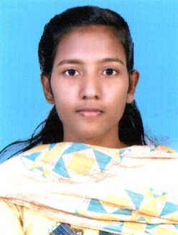
RIYA MOL SABU
Kunnel (H)
Perumpanachy P. O,
Changanacherry, Kottayam
Kerala- 686536

OBJECTIVES
+91 9605357082
riyamolsabu9644@gmail.com

To achieve a challenging position and utilize my skills and talents for the upgradation of the organization on par with standards.

PROFESSIONAL SUMMARY:

I describe myself as the one with good communication skills, a good listener and a sharp observer, as the one who is able to tackle any situations with patience and intelligence and a friendly person who is able to co-ordinate well along with the team members.

PERSONAL DETAILS

Name : RIYA MOL SABU

Date of Birth : 19/04/1998

Gender : Female

Father Name : Sabu Daniel

Nationality : Indian

Marital Status : Single

Mother Tongue : Malayalam

Religion : Christian

Language Known : English, Malayalam

EDUCATIONAL QUALIFICATION

Qualification | School/College | Year of Passing | Percentage of Marks
Bsc Nursing | CPAS, INE, SME Regional Centre Chuttipara, Pathanamthitta | 2019 | 60%
Plus Two | Jerusalem Mount H S S, Vakathanam | 2015 | 77%
SSLC | St. Peters H S S, Kurumpanadom | 2013 | 79%

Experience

- 5 Months experience in covid 19 second line treatment centre, Thenhipalam(po), Malappuram
7 Month experience in Gov Medical College Kottayam

AREAS
- Covid ward and ICU

KEY SKILLS

- Assessing Physical, Psychological and Psychosocial needs of the Patients
- Evaluating daily individual patient care
- Monitoring vital signs of the patients
- Administering drugs
- Meeting nutritional and elimination needs
- Emphasis on patient education and the nursing process

PERSONAL SKILLS

Goal Oriented, Hard Working, Willingness to learn good in problem solving, verbal and Written Communication skills, Team works and Interpersonal relationships

DECLARATION

I declare that the information and facts state here are true to the best of my knowledge and belief.
Place: Changanacherry
Date: RIYA MOL SABU

