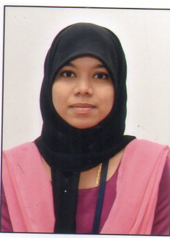

RESUME

Name : SELMA BEEVI A.R
Address & contact details : 16/196,Chulezhath parambil House
West karuvelipady
Thoppumpady P.O-682005
Ernakulam
Email : benbeevi143@gmail.com
Mobile : 8943017282
: 7356834213

PERSONAL INFORMATION

Husband name : Nasif Ben Haneef
Date of birth : 09/12/1997
Age : 24 years
Gender : Female
Marital status : Married
Nationality : Indian
Religion : Muslim

EDUCATIONAL QUALIFICATIONS

COURSE | NAME OF THE SCHOOL | UNIVERSITY/  BOARD | YEAR OF PASSING  &  PERCENTAGE/CGPA
Bsc.Nursing | Sri Devaraj Urs College of Nursing, Tamaka | Rajiv Gandhi University of Health Sciences | 2019  First Class
Plus two | E.m.g.h.s.school  Veli,fortkochi | Kerala Higher Secondary Examination Board | 2015  69%
SSLC | Loratto Anglo Indian High School,Saudi | Kerala board of Public Examination | 2013  92%

CLINICAL EXPERIENCE

NAME OF THE HOSPITAL | SPECIFIC AREA
R. L. Jalappa Hospital and Research Centre, Tamaka | - Basic principles of nursing  - Medical surgical nursing  - Health assessment  - Child health nursing  - Midwifery and obstetrical nursing
Sri Sai Foundation, Tamaka | - Mental health nursing

LINGUISTIC SKILLS

LANGUAGES KNOWN | WRITE | READ | SPEAK | UNDERSTAND
English
Kannada
Malayalam
Hindi
Tamil

RESPONSIBILITIES

- Maintaining accurate records,reports and medical information.
- Monitoring, recording and reporting symptoms of patients.
- Preparing patients for examination and treatment.
- Helping patients' caretakers or family members in taking care of patients.
- Prepare examination and treatment rooms.
- Maintain the supply of equipments required.

EQUIPMENTS USED

Defibrillator, cardiac monitor, suction apparatus, ambu bag, glucometer, ventilator, oxygen cylinder, pulse oximeter, infusion pump, laryngoscope, nebulizer, steam inhaler, ECG machine (12 leads), manual and automatic.

DECLARATION

I hereby declare that all the statements made in this resume are true and accurate to the best of my knowledge and belief.

PLACE : ERNAKULAM
DATE : 25/01/2022
SELMA BEEVI A. R

