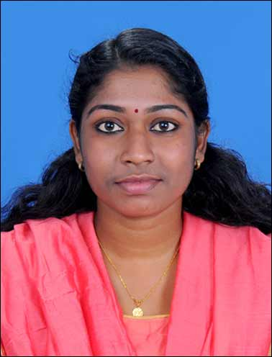
CURRICULUM VITAE

KRISHNENDU. K
Mobile: +918593088031
Email: krishnamahadevan8@gmail.com

OBJECTIVE:

To achieve a responsible person where my knowledge and skills can be implemented, in a team that dynamically works towards success and growth of the organization.

EDUCATIONAL QUALIFICATION

- Completed post graduation in MASTER OF PUBLIC HEALTH from the department of health management, U.C.M.E, MG UNIVERSITY KOTTAYAM.
- BACHELOR ZOOLOGY MODEL.II(VOCATIONAL) from ST; XAVIER’S COLLEGE KOTHAVARA VAIKOM KOTTAYAM MG UNIVERSITY
- HIGHER SECONDARY from, SMSNHSS Vaikom, under STATE BOARD OF KERALA.
- SSLC from SMSNHSS Vaikom under STATE BOARD OF KERALA.

ADDITIONAL QUALIFICATION:

- Underwent International Conference “ MEDALLION- 2012- 2013”
- “IPHACON 2013” International Conference in Calcutta.
- Organised an international conference “MEDALLION-2013-2014”
- “GLOBAL PUBLIC HEALTH ADMINISTRATION” 2014 International Conference in Chennai

SKILLS

- Good Communication skill
- Patient Management
- MS Office Application ( word , excel, power point)
- Well versed in use of Internet

EXPERIENCE
- 3 year and 8 Months experience in Public Relation Officer With Insurance/In Patient/ wing from specialists Hospital Ernakulam
- 2 year experience in Health insurance coordinator (cashless and reimbursement) from Life line super speciality Hospital Adoor

PROJECTS DONE

MPH PROJECT
- 1st semester- Conducted a study on “SOCIO ECONOMIC HEALTH STATUS”,
- 2nd semester – A General Study on “COUNSELLING AND PERSONALITY DEVELOPMENT” at TRADA(Total Response to Alcohol and Drug Abuse), KOTTAYAM.
- 3rd semester – A general study on “Effect of allergens in between yungsters
- 4th semester _ A study on “Problems associated with bedridden patient”
.

AREA OF INTEREST
- Counseling
- Public Relation
- Health Education
- Health Insurance wing(Companies and TPA )

OTHER QUALITIES
- Good Communication Skills.
- Time/Task management
- Organization
- Computer skill
- Phone communication skill
- Good Listener
- Good Team Management Skills

LANGUAGES KNOWN

- English, Hindi, Tamil and Malayalam

PERSONAL INFORMATION

- Birth date : 11-10-1990
- Gender : Female
- Marital Status : Married
- Nationality : Indian
- Permanent address: Thottuvelythara(H), Thottakom P.O., Vaikom, Kottayam, Kerala-686607
- Contact number : 8593088031

REFERENCE

Mr.RegiRam.S
Head of department
University College of Medical Education
Gandhinagar.P.O
Kottayam,kerala
Ph: +919447472919

Mrs.Tija Varghese
Head of Department(PRO/Insurance /ECHS/IP/Reimbursement)
Specialists Hospital Ernakulam ,North,Kochi – 682018
Ph: 7736540288

Mrs. Mojo Pappachan
HR Manager
Lifeline super speciality Hospital Adoor

Mr. George Chakkacheril
CEO Lifeline Hospital Adoor
Pathanamthitta

9446404780

Declaration

I hereby declare that the above said details are true to the best of my knowledge and belief.

Yours truly

Place: VAIKOM KRISHNENDU.K
KRISHNENDU.K

