JYOTHISH GEORGE
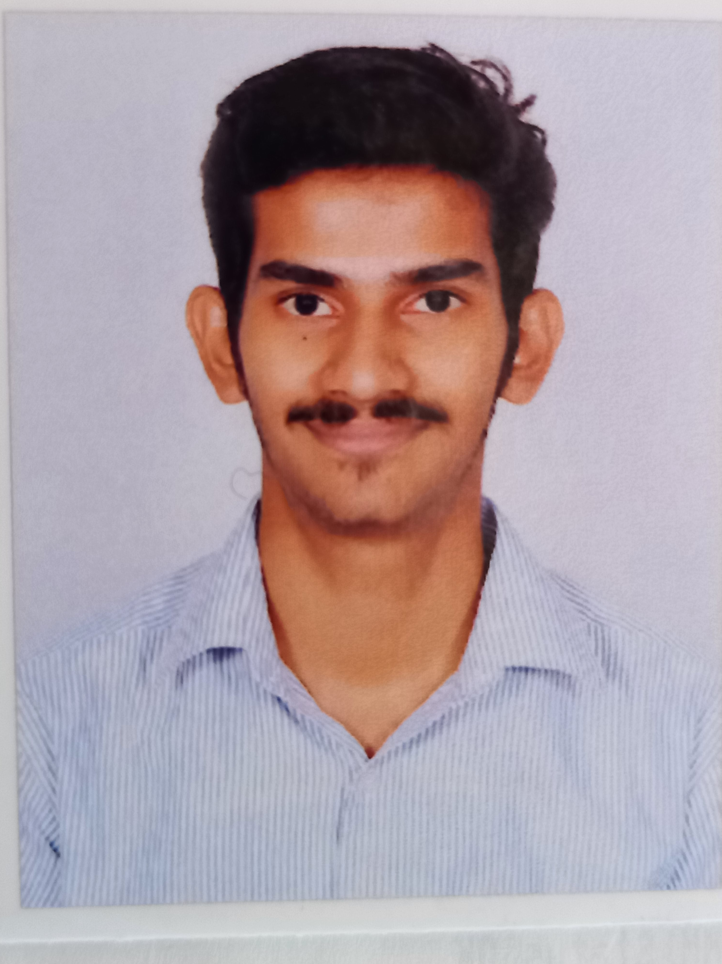
MBA (HA)
9605714714
Jyothishgrg77@gmail.com
CAREER OBJECTIVE
To work in an environment which encourage me to succeed and grow professionally where I can utilize my skills and knowledge appropriately to help my organization in achieving goals.
EXPERIENCE
- KASTURBA MEDICAL COLLEGE AND HOSPITAL
23/ SEPTEMBR/2021 to 22/OCTOBER/2021
Internship for 1 month
- TAKSHASHILA CONSULTING
17/ JULY/ 2021 to 18/ AUGUST/ 2021
Virtual internship
ACADEMIC QUALIFICATION
- A J INSTITUTE OF MANAGEMENT
MASTER OF BUSINESS ADMINISTRATION
(Hospital administration and Human resource)
Mangalore University
Persuing

- NAVAJYOTHI ARTS AND SCIENCE COLLEGE
Kannur University
Bachelor of Business Administration
62%

- ST THOMAS HSS THOMAPURAM
Higher secondary education
Commerce 82%

- Government high school Thayyeni
SSLC
85%

INTERPERSONAL SKILLS
- TEAM BUILDING
- COMMUNICATION SKILLS
- DECISION MAKING
- PROBLEM SOLVING

ACHEIVEMENTS AND AWARDS
- Best NSS volunteer in PUC & DEGREE
- Department secretary in Degree

ACTIVITIES
- Vivel workshop
- National service scheme
PERSONAL DETAILS
Father's Name: GEORGE T J
Marital Status: Single
Nationality: Indian
Date of Birth: June 12, 1999
Permanent Address: Thaivelikkakathu (h) Thayyeni (po) Kavumthala kasaragod (dist) Kerala
LANGUAGE
- English
- Hindi
- Malayalam
- Tami
REFEENCE
- Miss. Dr. ANKITA SARKAR

EXECUTIVE
Operations department
Kasturba Medical college
ankita.sarkar@manipal.edu
+91 8987578656

DECLARATION
I hereby declare that all the information furnished above is correct to the best of my knowledge. I am responsible for the authenticity of all the information.
JYOTHISH GEORGE
Place:
Date :

