JIYA JOSEPH K

RESUME
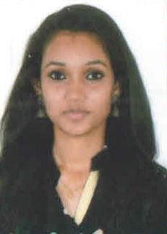

•

CAREER OBJECTIVE

8157996178

jiyajoseph1997@gmail.com

KANDAKKAPALLY HOUSE , PAI ROAD ,
PERUMPADAPPU

PALLURUTHY P.O , COCHIN
-
6

To work for an organization which provide me the opportunity to improve my skills and knowledge along with the organization objective. Always willing to innovate the new things which can improve the existing technology.

QUALIFICATIONS

2018 | Diploma in computer (DEOA) | First Class
2016-2018  Mahatma Gandhi University,  Vidyaniketgan College, Ernakulam | BA English | 75%
2015  Kerala State Board of Education  St. Mary's Higher secondary school, Fortkochi | Higher Secondary education | 70%
2013  Kerala State Board of education  O.L.C.G.H.S. Thoppumpady | SSLC | 72%

PERSONAL DETAILS

FATHER’S NAME : JOSEPH SEX : Female
MOTHER’S NAME : SHINI JOSEPH D.O.B : 02-12-1997
MARITAL STATUS : Single LANGUAGES KNOWN : English,Malayalam , Hindi

EXPERIENCE

Techniques known:-

➢ Data entry (English)
Experience:-

- 6 months of telecalling in TAP (Team For Anti-Pollution)
- 1 & ½ years of customer care consultant in Indus Motor, Thevara

STRENGTH
- Have good communication, management, planning, estimate approximation and analytical skills
- I am very cautious about deadlines and is careful to complete the job precisely.
- Quick learner, Hardworking dedicated person.
- Positive attitude to learning and improvements

EXTRA CURRRICULAR ACTIVITIES :

• Arts : Music, drawing ,Dancing
Crafting

DECLARATION

I hereby promise that above declared information is true to that of my knowledge.

Jiya Joseph K

