BIODATA

Vrindha V
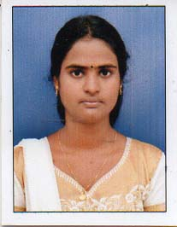
Vattathara House
Varanadu P.O
Cherthala
Alappuzha -688539
Kerala- India
Mob: 9447935488, 9747462371
E-mail:vrindhavijayant97@gmail.com

PERSONAL CHRONICLE

Date of Birth : 16th March 1997
Father’s Name : Vijayan T
Gender : Female
Marital status : Single
Religion & Caste : Hindu, Ezhava
Nationality : Indian
Languages Known : Malayalam, English, Hindi
Blood Group : O+ve

ACADEMIC CHRONICLE

- SSLC (86% Marks, March 2012- St. Mary’s G H S, Cherthala )
- Plustwo (86% marks, March 2014- Govt. G H S S, Cherthala)
- D.Pharm (80.4 % Marks, March 2017-Govt.T D Medical College, Alappuzha)
- B.Pharm (College of Pharmaceutical sciences, Kottayam)

EQUIPMENT SKILL

- Auto Clave
- Hor air oven
- Tablet punching machine
- Capsule filling machine

EXPERIENCE
- 6 month, Govt. Medical College, kottayam
. 6 months in medical store
DECLARATION

I hereby declare that the details furnished above are true to the maximum extent of my knowledge.

Place: Cherthala
Date:04/12/21

