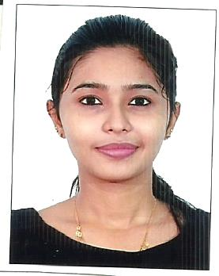
MARY ASHEETA P A
Pharmacist
9/429 A Puthanparambil House
Holly Cross Road, Nazareth
Mattanchery P.O 682002
Cell No : 9656006876/9633558278
Email : maryasheeta101@gmail.com D.O.B : 26 / 08 / 1997

PROFESSIONAL SUMMARY
Patient service-Oriented Pharmacist with Diploma in Pharmacy degree and 3 month training experience, excellent track record of maintaining positive relationships with customers.

SKILLS HIGHLIGHTS
- Drug distribution professional
- Attention to detail
- Computer literacy
- Efficient and Accurate
- Inventory management
- Good interpersonal skills

PERSONAL DETAILS
Father`s Name : Antony P J
Sex : Female
Religion : Christian
Marital Status : Single
Languages Known : Malayalam, English

EXPERIENCE
LISIE HOSPITAL, Ernakulam - Trainee Pharmacist APRIL 2018 - JULY 2018
6 months experience in JISHY HOSPITAL MUNDAMVELI KOCHI
Still working on JUBILEE MISSION MEDICAL COLLEGE AND RESEARCH CENTER, THRISSUR

EDUCATION
DIPLOMA IN PHARMACY
Completed In 2018
LISIE College of Pharmacy, Ernakulam

PLUS TWO - BIO MATHS
Completed In June 2015
St.Marys Anglo Indian Girls Higher Secondary School, Fort Cochin

S S L C
Completed In March 2013
St.Marys Anglo Indian Girls Higher School, Fort Cochin

DECLARATION
I do hereby declare that the above particulars are true and correct to the best of my knowledge and belief.

Place : Ernakulam
Date : MARY ASHEETA P A

