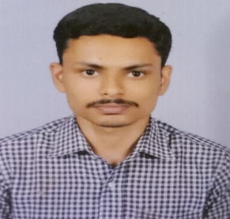
SHIFAS.VB
Vadacke kottoor(H), Naduvath nagar.PO,
Cherthala,Alappuzha:-688 526
Mob: +919946686431
E-mail: shifasvb@gmail.com

Objective

- Aspire to join a reputed company to perform my best abilities as a IT professional.

Technical Skills

- Sound familiarity with, Windows XP and Windows 7 at the user level, including user and
Application installation
- Familiarity with Microsoft Office, Printing and Computer basic Hardware’s
- Trouble Shooting of application Issues
- System installation, Assembling.

Human Skills

- Positive attitude
- Fantastic ability to learn new material quickly
- Uncommon ability to work independently and as a part of the team
- Inspiring
- A Proven record of reliability, the ability to perform under time constraints and good judgment under pressure

Education

Course university/school year of passing

SSLC Vaduthala Jama-ath HSE 2007

HSE Vaduthala Jama-ath HSE 2009

Diploma In
Computer Engineering Govt.pollytechnic Kalamassery 2012

Hardware & Networking Aptech 2013

Technical Study
- BASIC HARDWARE MAINTANANACE(A+)
- MCITP
- CCNA
- HTML5,CSS,BOOTSTRAP,JAVASCRIPT,JQUERY,AJAX
- PHP,CODEIGNITER
- MYSQL

Academic Projects

- Main project
- Hotel Booking
- For booking online rooms
- Language(front-end: PHP, back-end: MYSQL)
- Mini project
- Cyber Village
- Using in cyber park for finding proper place for an emerging company
- Language(front-end:PHP back-end: MYSQL)
- Mini project
- Networked Panchayat
- Language(front-end:.net back-end: MYSQL)
- Main Project
- Medical Shop Management
- Language(front-end: Visual Basic, back-end: Ms Access)

Personal Particulars
Date of Birth : 14/05/1991

Age : 28

Languages : English, Malayalam, Hindi

Caste : Islam, Muslim

Father : Basheer.V.K

Permanent
Address : Vadakke Kottoor (H)
Naduvath nagar.PO
Cherthala,alappuzha-688 559
.
Marital Status : Married

Experience

- 6 Month Experience as a Type Writing in DBN Cochin
- 4 Month Experience in Cochin Shipyard
- 2 Year Experience as a Instructor Post in Govt.ITI, Kayamkulam

Declaration

I hereby declare that the above written particulars are true to the best of my knowledge and belief.

Date: Shifas.V .B
Place: Arookutty

