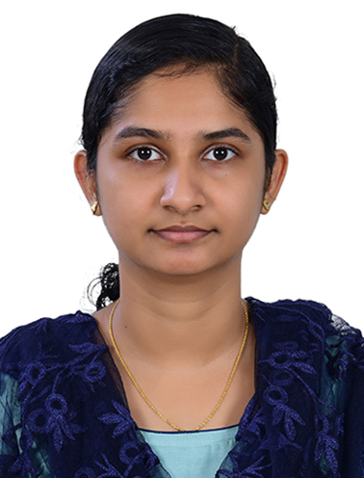
RESUME

STEFY JOSE
EMAIL ID: stefyjose98@gmail.com
MOBILE NUMBER:+919447974685
CAREER OBJECTIVE:
To assist in anaesthesia with equipment ( old and modern)in multi-specialty hospitals as well as mission hospitals in all the ways beneficial for the needed and to prove the knowledge and skill attained.
ACADEMIC PROFILE:
Exam passed:
- SSLC of Board of Public Examination Kerala: March 2013
Mahatma Gandhi Memorial High School, Puthencruz, Ernakulam, Kerala
- Higher Secondary Examination Kerala. : March 2015
Mar Coorilose Memorial Higher Secondary School, Pattimattom, Ernakulam, Kerala
Professional qualification:
- Bachelor of Science. Operation theatre and anaesthesia technology: July 2015- August 2018
Christian Medical College Vellore, Tamilnadu, India
Under Dr. M.G. R Medical University Tamilnadu
PROFESSIONAL EXPOSURE:
Assisted the anesthesiologist with the following :
- Pre anaesthetic assessment
- Cardio-thoracic surgeries, Liver transplantation, Renal transplantation, Paediatric surgeries, Neurosurgeries, Obstetric and Gynecology surgeries, Orthopedic surgeries, ENT surgeries, Urology( Nephrology), Plastic surgeries and reconstructive surgeries, Dental surgeries, Laparoscopic surgeries, General surgeries, Spine surgeries
- Postoperative care
- Also trained to assist the anesthesiologist in bronchoscopy and outside operation theatre areas like MRI, DSA, Cath lab, Labour room(labor epidural), etc.
EXPERIENCE IN HANDLING MACHINES AND TYPES OF EQUIPMENT IN OT
- Anaesthesia machines( Boyle's machine, Datex Ohmeda excel, Aestiva, Dragger, etc.)
- Vaporizer
- Breathing circuits( Bain's circuit, Jackson Rees circuit, closed circuit, etc)
- Video laryngoscopic equipment( Glidescope, C- Mac, King's vision)
- Defibrillator
- Pressure Monitoring transducer
- Blood gas analyzing equipment( ABG machine, I- stat)
- Jet ventilation
- Infusion pumps
- Fiber optic, etc
TECHNICAL QUALIFICATIONS
- Airway management ( intubation)
- Peripheral line insertion
- Drug administration
- Pre anaesthetic evaluation
- Intraoperative monitoring and management
- Assisting the anaesthesiologist in all types of anaesthesia( general anaesthesia, subarachnoid block, epidural anaesthesia, caudal analgesia, peripheral nerve blocks)
- Assisting for central line, arterial line, peripheral line
- Managing pipeline gas supply as well as cylinders
- Remote location anaesthesia ( CT, MRI, Cath Lab, etc)
- BLS and CPR
- Postoperative management etc
ANAESTHESIA EXPERIENCE
Assisted the anesthesiologists in providing local anaesthesia, general anaesthesia, regional anaesthesia( SAB, epidural, caudal), nerve block and also I am having experience in intubation( endotracheal tubes, LMA), IV line insertion, preoperative assessment, mask ventilation, intraoperative and postoperative monitoring and documentation, nasogastric tube insertion. I have also done the SAB under the supervision of an anesthesiologist.
WORK EXPERIENCE
- Internship: 1 Jan 2019- 2 Jan 2020
Christian Medical College Vellore, India
2400 bedded multispeciality hospital and NABH accredited
- 20 Jan 2020 - till the date
Mar Baselios Medical Mission Hospital Kothamangalam, India
360 bedded multispeciality hospital with NABH primary level
POST:
Anaesthesia technologist/ assistant
PERSONAL PROFILE
Name: STEFY JOSE
Father's name: E.Y JOSE
Permanent address: Echickamandanath house, Varikoli P.O, command, Ernakulam, Kerala, India, PIN-682308
Mobile number: +919447974685
Date of Birth:08/02/1998
Gender: female
Nationality: Indian
Marital status: unmarried
Language is known: Malayalam, English, Hindi, and Tamil
DECLARATION
I hereby declare that all information enclosed is true.
Place: Chemmanadu
Date:06/09/2021

