RESUME

Dr. Niyati Patel

Education
Bachelor of Dental Surgery done from A B Shetty Memorial Institute of Dental Sciences, Mangalore (NITTE University)
Passed in the year September 2020
DCI registration done under KSDC (reg. No. 49318 A)
Clinical Aesthetic Dentistry course done at Root Canal Point under Dr. Jojo kottoor

Experience
Experience working at clinic
(Elite dental studio, Elamakkara)
(Nutri dental multi-speciality clinic, near High Court)

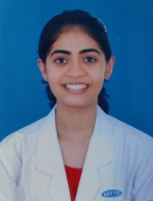
Personal INFORMATION
Date of birth- 16/10/1996
Address- Abad marine Plaza, near High Court, cochin-18
Phone number- 7026184155
Email address- patelpn96@gmail.com

Expectations
I will work to the best of my capacity to give the best treatment possible
Salary expectation – negotiable

