BIO-DATA

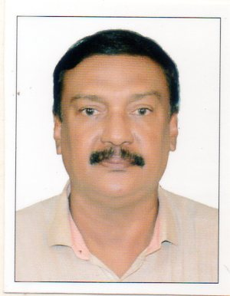
FEROZ AHMED
feroz15561ahmed@yahoo.com
Kalluparambil House,
Near St. George Church,
Vadacode P O,
Kangarappady , Kochi – 682021
Mob: 9645055948

Objective:
To get a placement which enables to me to make use of my abilities and work in a competitive environment.

Personal Details:
Date of Birth : 15/05/1961
Educational Qualification : Graduate
Technical Skill : Computer Literate
Languages Known : Fluency in English, Hindi, Malayalam, Tamil

Work Experience:
Sales Executive & Store Supervisor for a Furniture firm in Saudi Arabia,
1984-1990.
Business Development Officer & Store Keeper in a Spices firm New Delhi
1990-2007.
Site Store Keeper for Daewoo at their Q chem Project in Qatar 2008-2010.
Supervisor in Qatar Precast 2010-2012.
Store Keeper in Saudi Bin Laden Group in Qatar 2013-2017.
Worked as Administrator in a Clinic at Chalakudy 2018-2019 June.

