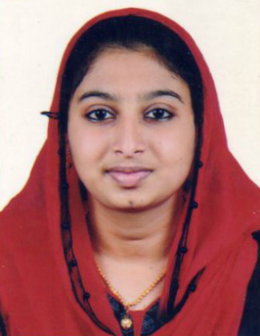

Niza P Muhammed
Pallathupara House
Vengola P.O, Meprathupady
Perumbavoor, Ernakulam Dist
Kerala, India, Pin-683556
Mob. No: 9400693436
Email id: nizapmuhammed6472@gmail.com

ABOUT ME
I,M Niza P Muhammed works to succeed on an environment of growth and excellence which provides me job satisfaction, self-development and help me achieve personal as well as organizational goals.

EDUCATIONAL QUALIFICATION
Sl. No | Name of the course | College/ University | Year of Completion
1 | B Pharm | Chemists College Of Pharmaceutical Sciences And Research, Kerala university of health sciences | 2017
3 | Higher Secondary | Govt. Higher Secondary School, Kadayiruppu | 2013
4 | SSLC | National School, Perumbavoor

ACHIEVEMENTS
- Post Metric Scholarship in School Level
- 10th Topper in School
- HDFC Bank Scholarship in College Level
ACADEMIC PROJECTS
Project Type : Review
Project Name : Electronic Aspirin
Description : A Migraine Free Implant

EXPERIENCE
05 - July - 2017 / 05 - August - 2017
Rajagiri Hospital
Pharmacy Department
Description :- Completed the Internship Training in Pharmacy Department of Rajagiri Hospital
for a Period of 30 days as part of course curriculum.

08 - August - 2017 / 26 - April - 2018
Rajagiri Hospital
Pharmacy Department

01 - June - 2018 / 31-January-2020
Pharmacist
Kripa Medicals, Perumbavoor

SKILLS
- Communication | - Organization
- Creativity | - Leadership
- Teamwork

HOBBIES
- Research
- Cooking
- Travelling

