Mekha Raj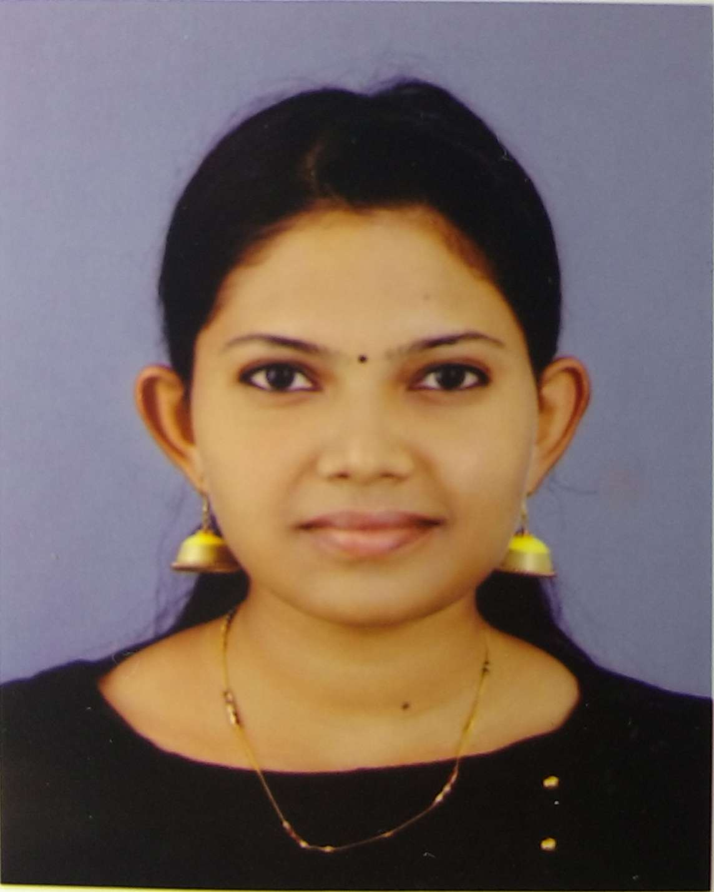
Srivilla, Karavaloor (P.O), Punalur, Kollam District, Kerala-691333,India
Email: mekharajsree@gmail.com, Mobile: +91 8220 110 698
Passport No: M0547534, RCI No: A44230

Career Objective:
To work in a continuous learning environment were my Speech Language Pathology and Audiology knowledge and skills could be put to test, gain valuable hands on experience, and thereby contribute effectively towards organizational and professional success.

Professional Experience:
Current Organization: National Institute for Physical and Medical Rehabilitation (NIPMR), Kallettumkara, Thrissur.
Designation: Speech Language Therapist and Audiologist
Tenure: May’ 18 till date.

Previous work experiences
- My First Steps, Chennai, Tamilnadu, India
Designation: Speech and Language Therapist
Tenure: May’14 – February 2017
Organisation background: ‘My First Steps’ is an early multidisciplinary rehabilitationcentre based in Chennai, India. The organization engages in physiotherapy, speech and language therapy, sensory-integration therapy, occupational therapy, vision therapy and special education, providing a better quality of life to the young patients. The patient disorders include Cerebral palsy, Autism Disorder, Apraxia, Hearing loss, Misarticulation, Stuttering, Cluttering, Cognitive impairments, Dysphagia and Pragmatic language impairment.
Beyond engaging with young patients, I’m competent to manage Adult Speech & Language disorders and Audiological Evaluations.

2. Extension centre of National Institute of Empowerment of Persons with Multiple Disabilities (NIEPMD) located at Port Blair, Andaman & Nicobar Islands.
DESIGNATION: Worked as a Speech Language Therapist and Audiologist. The population includes paediatric, adults and geriatrics – early intervention & rehabilitative services includes Physiotherapy, Occupational Therapy, Speech Therapy, Special Education & Vocational Training.
TENURE : March 2017- February 2018

Educational Qualifications:
Degree | Passing Year | Institution | University | Percentage (%)
Bachelors in Speech Language Pathology and Audiology | 2010-2014 | Dr.S.R.Chandrasekhar Institute Of Speech and Hearing. | Bangalore | 59.6%
Second year Pre-University | 2008-2010 | St.Goretti HSS Punalur | Kerala | 82%
SSLC | 2008 | St.Goretti HSS Punalur | Kerala | 85%

Academic Experience:
Speech Pathology
- Fluency: stuttering, normal non fluency and cluttering
- Voice: Post-surgical intervention, disorders of voice quality and functional voice disorder
- Phonology/articulation: cleft lip and palate, misarticulations, phonological disorders.
- Child language: autism, attention deficit hyperactive disorders ,delayed speech and language, specific language impairment, mental retardation, cerebral palsy ,language learning disability and down’s syndrome
- Adult speech and language disorders: Aphasia, Dysphagia ,Dysarthria, Apraxia and Voice

Audiology
Accomplished good clinical skills in the diagnosis and intervention of CAPD (Central Auditory Processing disorder), auditory neuropathy, Auditory verbal therapy for cochlear implant recipients, Hearing aid dispensing skills.
Accomplished good clinical skills in the diagnosis and intervention of Hearing disorders this includes disorders like:
• Diagnosis of all types and degrees of hearing loss, also patients with Auditory Neuropathy.
• Articulation therapy for the individuals with Hearing Loss.
• Auditory and Speech and Language assessment of children pre- and post- CI.
• Attended camps conducted by the Institution for screening children with Speech, Language and Hearing Disorders.
• Attended various seminars and talks conducted by the Institute on Cochlear Implants, Oto-Acoustic Emissions, and Workshop on implantable hearing solutions.

Conferences and Seminars Attended:
No. | Title | Attended at
1 | Seminars on Cochlear Echoes | Dr.S.R.Chandrasekhar Institute Of Speech and Hearing , Bangalore-2011
2 | Issues related to assessment and diagnosis in speech language disorders | Dr.S.R.Chandrasekhar Institute Of Speech and Hearing , Bangalore-2012
3 | Recent advances in auditory technology | All India Institute of Speech and Hearing,mysore-2012
4 | National workshop in phonological disorders: clinical prospective. | All India Institute of Speech and Hearing,mysore-2012
5 | Noise measurement and conservation of hearing in industrial workers | Dr.S.R.Chandrasekhar Institute Of Speech and Hearing , Bangalore-2011
6 | Traumatic Brain Injury : A Multidisciplinary Approach | Dr. S.R. Chandrasekhar Institute Of Speech and Hearing , Bangalore-2015
7 | ISHACON | At Chennai – 2013-2014
8 | Annual International Conference On Expressive Arts Therapy- Expressions Of The Soul | Women’s Christian College – Chennai, 2017
9 | Unlocking AAC concepts in children with complex communication needs | National Institute of Speech and Hearing- 2019.
10 | Workshop On Management Of Dysphagia In Paediatrics And Adults | NIPMR- Thrissur, 2018
11 | ISHACON | NIMHANS , Bangalore 2019- 2020
12 | 4th - Annual Multidisciplinary National conference and workshop | CDMRP, Kozhikode- 2020
13. | Recent Developments in Amplification Technology. | AVMC- Hospital Pondicherry-2020
14. | State Level Workshop on AAC for Children with Cerebral Palsy & Multiple Disabilities. | NIPMR -2020

Paper presentations:

Clinical Conference done on the topic - DOCUMENTING & REPORTING THE CLEFT LIP & PALATE SPEECH USING UNIVERSAL PARAMETERS during the academic year of 2012-2013.
- Paper Presentation done for the ISHACON (2013-2014) - KNOWLEDGE AND IMPLEMENTATION OF AAC INTO PRACTICE - A PRELIMNARY STUDY.
- Paper presentation done for the ANNUAL INTERNATIONAL CONFERENCE ON EXPRESSIVE ARTS THERAPY- EXPRESSIONS OF THE SOUL (2017) on the topic of EXPRESSIVE ARTS AND EARLY INTERVENTION FOR YOUNG CHILDREN WITH COMMUNICATION DELAY.

Camps: For screening purpose in children with speech, hearing and language problems conducted in our Institute of speech and hearing. Hearing screening conducted in hospitals in Bangalore and Mysore (Karnataka).

Internship Experience:
Accomplished 10 months of internship in the following centres at Bangalore 2013-2014:
- National Institute of Mental Health &Neuro Sciences (NIMHANS) - 2 months
- Apollo Hospital - 1 month
- Outreach Extension Centre-Dr.SRCISH Rehabilitation Centre – 1 month
- ASHA special school – 2month.
- Dr S R Chandrasekhar Institute of Speech & Hearing – 3month.
- Divya Down’s Developmental Trust – 1month

References:
Can be provided on request.

I, Mekha Raj, do hereby affirm the authenticity of the aforesaid personal and professional details.

Mekha Raj
Place: Ernakulam, Kerala/India
Date: February/ 2020

