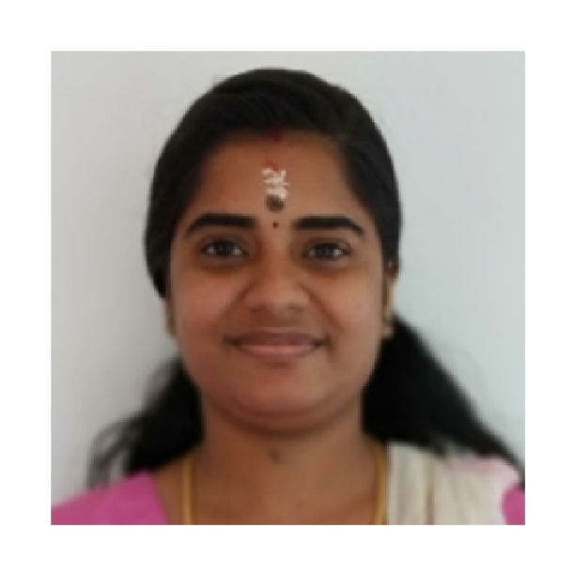
From,
Mrs. Vineetha Vijayan
Kumbalath Krishnamrudham House
S.H. Mount
Nattassery P.O
Kottayam, Kerala
Mob: 7022859664,6363889539
E mail : vinuvineetha92@gmail.com

To,
The Human Resource Manager

Sub: - Application for the post of staffnurse

Respected Sir/Madam,
It is known from reliable sources that there is a vacancy forStaff Nurse in your esteemed firm; I would like to offer my candidatefor the same.

If I’m selected I shall do my best for your organization, anticipating favorable reply in this regard.

Thanking You,

Date:

Place:Kottayam, India.

Career Objective

To obtain a position as a Nurse to utilize my skills and expertise in patient care.

Strength

I am self-motivated, I can communicate reasonably well, I have a good level of emotional intelligence to get along with different types of patients and colleagues and I can keep myself cool in hard times, I am trained to be proactive.

Personal Details

Name : VineethaVijayan

Father : Mr. Vijayan Nair

Age : 16, December ,1992

Sex : Female

Marital Status : Married

Nationality : Indian
Contact Number : 7022859664

Religion& Caste : Hindu

Academic Qualification

- S.S.L.C : Holy Family High School
YEAR : 2008
Plus Two : Vocational Higher secondary School
YEAR : 2009-2010

Professional Qualification

QUALIFICATION & INSTITUTION YEAR
Bachelor of Science in nursing HILLSIDE COLLEGE OF NURSING 2010_2015

Experience Details

- Worked as a nursing Tutor in Hillside college of Nursing from August 2015-March 2016.

References

Ms.Vijayalakshmi

Principal
Hillside College of Nursing,Bangalore
Gubbalalacross ,Raghuvanahalli
Kanakapura Road.

Ph No:080-65466176

- Worked as a staffnurse in Sevakshetra hospital (Medical &Surgical ward)Banashankari from march 2016-october 2016

References

Mrs.Shobha
Sevakshetra Hospital
Banshankari,2ndstage,Bangalore
Ph no:8431205606

3.

Institution: NU Hospitals, C.A 6, 15th Main, 11th cross, Padmanabhanagar, Bangalore.

Designation: Procedure Room/Minor OT staff

Period: April 5th 2017to March 19th 2019

Nature of work :- Urology Specialty Nurse.

- Procedure Trainer

- Nurse educator

Nursing duties in procedure room:

1. Perform/Assist procedures in the department.
2. Ensure the normal functioning of all equipment and report to the concerned personnel, if required.
3. Maintain duty roster and ensure the smooth functioning of the department.
4. Observe the standards of cleanliness within the department and report deficits.
5. Perform urological radiology procedures in the radiology department.
6. To be able to give information and advice about health promotion.
7. Delegate tasks to junior nurses and ensure that it is carried out in time.
8. Ensure the effective documentation of all patient care adhering the standards.
9. Perform procedure in the community for emergency /bed bound patients.
10. Report Needle Stick Injury to the hospital infection control nurse.
11. Keep up to date with changes in clinical practice and change practice of self and others as appropriate
12. Perform store indent to maintain stock.
13. Come to the hospital in absence of urology doctor, if any of the patients need emergency procedure
14. Ensure all the nursing services are in compliance with patient care related safety policies.
15. Assist Manager Nurse in the implementation of competency based training programmes.
16. Ensure required mandatory and competency based training is kept up to date.
17. To report untoward incidents to the higher authority.

Special expertise in procedure room:

- Assist all cases following aseptic precautions
- Wound dressing
- IV cannulation
- Foley catheterization and Foley exchange
- SPC exchange and removal
- Trocar cystostomy
- IJC/FC suturing and dressing
- IJC/FC removal
- CIC Teaching and Initiation
- ICD removal
- Incision and drainage
- Urethral calibration
- Bladder neck dilatation
- PCN wash
- PCN tube removal
- Ryles tube insertion and removal
- Suture/stapler removal
- Collection of urine sample from Foley/SPC/PCN
- Suturing
- Supra pubic aspiration of urine
- Urotherapy
- DT removal
- ECG
- Mitomycin instillation

Uro-radiological procedures

- RGU
- MCU-Suprapubic technique and catheter technique
- IVU
- Nephrostogram

References

(1). Dr. Venkatesh Krishnamoorthy
Medical Director and Head of department Urology
NU hospitals, Padmanabhanagar,
Bangalore.PIN: 560070
Ph.080 4248 9940

(2). Dr.Maneesh Sinha
HOD of Urology Department
NU hospitals,Padmanabhanagar,
Bangalore.PIN:560070
Ph.080 4248 9926

Language Proficiency

ENGLISH, HINDI, MALAYALAM, KANNADA, TAMIL

PARTICIPATION

- ACLS AND BLS FROM AHA
- Hospital Infection Control Committee

Declaration

I, Vineetha, do hereby declare that the above written particulars are correct and true to the best of my knowledge and belief.

Vineetha
Place: Kottayam

Date:

