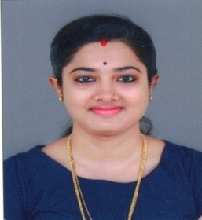
BIO-DATA

HARSHA MOHAN
MUDOOR HOUSE, EDAYAPPURAM, ALUVA,
ERNAKULAM
Email : harshagibin@gmail.com
Contact : 8086694204
CAREER OBJECTIVE
To be part of organization that provides an atmosphere of mutual growth and benefits, where I can show my potential.
PERSONAL DETAILS
Father’s Name - E.G. Jaya Mohan
DATE OF BIRTH - 17-12-1991
SEX - Female
Marital Status - Married
Nationality - Indian
Languages known - Malayalam, English, Hindi, Punjabi
EDUCATIONAL QUALIFICATION
- Xth Passed from CBSE(2007)
- XIIth Passed from PSEB(2011)
- Graduation in Journalism & Mass Communication(2014)
OTHER QUALIFICATION
- Knowledge in Computer & Internet
- Certificate in Business Basics from The Institute of Chartered Financial Analysts of India, Sikkim
PROFESSIONAL EXPERIENCE
- Have completed 3 months internship with INDIAVISION NEWS
- Worked as a BUISNESS DEVELOPMENT EXECUTIVE in an Educational Institution.
ACHIEVEMENTS & EXTRA CURRICULAR
- Certificates For Participating & Winning in various Media Fests
- Participated in 11th NATIONAL YOUTH PARLIAMENT, sponsored by Ministry of Parliamentary Affairs, Government of India, New Delhi
- Won National Level 1st PRIZE in Folk Dance(Group)
PERSONAL SKILLS
- Highly Organized & Efficient
- Ability to work independently or work as part of a team
- Good Interpersonal Communication Skills
HOBBIES
- Reading, listening to Music

DECLARATION
I hereby declare that all the above information is correct to the best of my knowledge and belief.

Date: 16-01-2020
HARSHA MOHAN
Place: Aluva

