 | Charly chackochan |  |  | 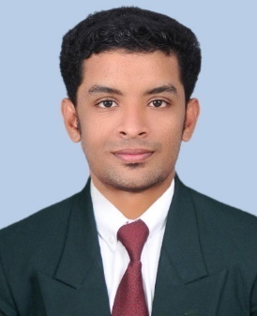
Charly chackochan  Kooranvattathara house  Jews street, North Paravoor po, Ernakulam, Kerala, India  Pin-683513  Phone no: +918281543186  chackochy.charly1991@gmail.com |  | Objective  Detail-oriented technical knowledge with 6+ years of experience in managing different phases of engineering operations, looking for construction/various production industries. Capable of handling multiple projects at a time with minimum supervision. Motivated to offer the highest quality of services with a complete focus on safety, environmental, and health issues
Education  - Professional Diploma in Industrial Instrumentation, Fire & Safety  - Post Graduate Diploma in Industrial Automation  Certification:  - iosh- Managing safely  - COSHH- Control of Substances Hazardous to Health  - First Aid at Work  - Stcw/stsdtds  - Advanced training in DCS  - Post Graduate Diploma in Industrial Automation  (TUV Rheinland certified) |  | ExperienceTotal 6+yrs  1/7/2014 still working  •Craft hospital and research center  Key duty:  1.Field inspection, 2. comparison with control room data 3. complaints identifying 4. Hand over the complaints for approval in other departments  5. complaints rectification, 6. Record creating  7. with additional duty of taking safety class for all hospital staffs/safety inspection  8. Safety officer in new 300 bed hospital project (under construction)  06/2013 to 06/2014  Control room in charge in production  •Thekkinedathu aluminum company  Key duty:  1.Field inspection of aluminum production area,  2. control room operator duty
Highlights  1.Knowledge in PLC, SCADA and troubleshooting in electrical systems  2. Knowledge in various basic instruments using in industries  3. Assistant electrician certified  4.experienced in Sewage/effluent/sweet water plant/automation systems of buildings/instrumentation technician/As safety officer  5.practicing MEP with fire protection system drawings  6.computer proficiency |  | Trained by  1. Fire and rescue training,  In every 6 months gap, Fire and rescue department of Kerala  2. Electrical safety training,  Kerala State electricity board  3. Lift safety and emergency evacuation training  From safety Oﬃcer, OTIS Elevator company  4.First Aid procedures training,  senior Doctors, CRAFT Hospital and research Centre  skills  - A good communicator  - The Power of Persuasion  - A Born Leader  - An Organised Mind  - Attention to Detail

Personal information
Date of birth: 09/08/1991
Passport number: N8089027
Cdc no: KOL 119110
INDoS no: 19ZM9385
Driving license, no: 42/3580/2011(Indian union, Kerala state)
Languages known English, Hindi, Malayalam, Tamil
Hobbies : Traveling ,Rooming with friends

