CURRICULAM VITAE
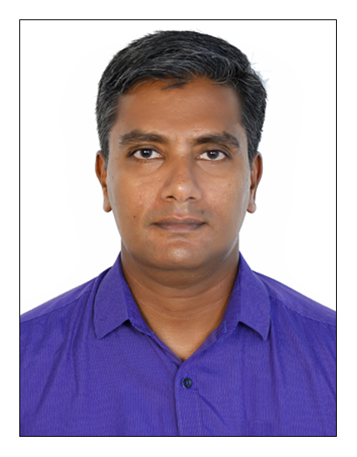
Manoj kumar I S

Indunivas (h)
Kuzhimattom p o
KOTTAYAM (DIST)
KERALA (state)
INDIA PIN-686533

Mob -+9400316952 (whatsapp & IM0)

- E-mail: ismanojkumarster@gmail.com

OBJECTIVE

To obtain a position of suitable post in a your organization this allows technical, personal and financial growth

TOTAL EXPERIENCE - 17 YEAR IN COMPLETION as ASSISTANT MANAGER (2015 to till date)

RECENT EXPERIENCE

Organization : Amrita institute of Medical sciences
and Research Center
(A I M S) KOCHI,Kerala,INDIA

Designation : ASSISTANT MANAGER (2015 to till date)
HANDLING INSTALLATIONS, PRVENTIVE MAINTENANCE AND BREAK DOWNS OF ALL CATEGORY OF MEDICAL EQUIPMENTS .

The present post is leading 14 biomedical officials. This is including two senior engineers, three senor technicians and nine technicians. Handling and scrutinizing all contracts between companies and hospital, keeping an updated status of all equipment on day to day basis. We are monitoring the preventive maintenance and calibrations of all biomedical equipment until the decommissioning date, maintaining minimum down time for all equipment with all available facilities.
A I M S is an I S O 9001-2000 & NABH acertified fully networked multi specialty hospital with fully digitized radiology department and a comprehensive well equipped clinical laboratory. Presently the hospital comprises of 24 operating rooms and 1600 patient beds. Facilities here are the finest in India and Equivalent to leading medical center around the world

ACADEMC PROFILE

1997-2000 : 3-years Diploma in electronic engineering
Govt: poly technique, Kottayam
With 64% marks
1994-1996 : National trade certificate in electronics
GOVT I t I, ETTUMANOOR
With 69% marks
1992-1994 : ,s b college changanacherry
With 49 % marks
1992 : S.S. L.C
N S S H S C hingavanam
With 81% marks

PREVIOUS experience

SENIOR TECHNICIAN (2006Januvary-4 to 2008
March-19 and 2015 may24 to till date)

Organization : Oman Shapoorji Construction & Co
LLC
Designation : Senior Supervisor (2008 March-27 ---2010 March 27)
IN NIZWA HOSPITAL of SULTANATE OF OMAN

PREVIOUS EXPERIENCE : Epsilon diagnostics (A dealer of lab:
Equipments) Edapply, Kochi
Designation : Service Engineer (September-3-2000 to December
2006)
RESONSIBILITIES : Worked as service engineer for Biochemistry analyzers, A.B.G machines & Blood
Cell Counters

EQUIPMENTS HANDLING

SURGICALDIVISION

Surgical table MAQUET, STERIS, QUANUM 3080, 3085 SP,

Surgical light MAQUET, STERIS, PHILIPS, I

ECG MACHINES

PHILIPS
MORTARA
GE
SCHILLER

TREADMILLS
MORTARA
SHILLER

EEG MACHINES
NATUS
PHILIPS HD EEG

UROLOGY EQUIPMETS
LABORIE

Dialysis machines

b braun

fresenius

LAB EQUIPMENTS

Biochemistry analyzers (semi auto type) Olympus
Biochemistry analyzers (fully auto type) Olympus
Blood cell counters Abbott -cell dyne, Nihon Kohden
Automated coagulation analyzer Diagnostica stago,
start compact

A B G Machines COBAS ,RADIOMETER

Immuno assay analyzer J&J E C I Q, BIORAD

Micrscopes Nikon, LABOMED, OLYMPUS

H.P.L.C MACHINES SHIMADZU, BIORAD D-10

COLORIMETERS OF ANY TYPE

I.C.U EQUIPMENTS

Ventilators S l e 2000 HFO, ENGSTROM, HAMILTON .Engtrom care staTION, SERVI S AND i
Defibrillators Philips, Nihon Kohden

Anesthesia machines GE,Spacelabs

Monitors space labs, PHILIPS, GE

Infusion pups& syringe pumps B Braun, BAXTER, FRESENIUS

ECG machines Phlips TC20

Incubators Dragger

Electro sugical units Valleylab

Tread mill 吗otrara, SPACE labs burdic

Xray Siemence, Shimadzu

Endo&Laproscopic systems Karl storz & olympus

Heart lung machines sarns

I A B P Arrow

Neuro micro scope Karl zeiss

Test equipments Fluke

Dialysis machines

b braun dialogue +,

fresenius 4000s

DENTAL EQIPMENTS

Dental xray sirona, Siemens

JOB DESCRIPTION

- Worked with highly trained doctors and engineers
- Jobs include testing, installation repairing, calibration and maintenance of equipments
- Works involved using hand tools such as multimeters,soldering ions and delicate testing and measuring equipments
- Performed regularly scheduled preventive maintenance work on patient care systems in assigned departments and keeping of an accurate records of time and materials used in the performance during these duties
- Responded to break down calls from various departments

Personal details

Fathers name : p .i. Sredharan nair

Date of birth : 10/03/1977

Marital status : MARRIED

sex : male

nationality : indian

languaes known : CAN SPEAK english, HINDI, AND MALAYALAM
UNDERSTANDS TAMIL AND ARABIC

referances

BABU S S (ph:+91 92238 11594)
DGM of bio-med dept
Amritha hospital
Kochi
KERALA

prasan anurup marate (ph:09461633757)
biomedical engineer
nizwa hospital
sultanate of oman

DECLARATION

I hereby declare that the information given above is true to the best of my knowledge and belief.

MANOJ KUMAR I S

