Personal Information 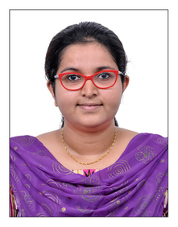

- Name - Sruthi Shashikumar
- Age - 26yr
- D.O.B - 31.08.1993
- Address - 9A, Lotus Padmahara Apartments.
Near Raghavendra Madom.
Statue Junction. Tripunithura.
Ernakulam. Kerala – 682301.
- Contact No. - +91 – 9446062643
- Email - sruthi.skaygee93@gmail.com

Educational Qualifications

M.B.B.S

- Name of Institution – Sree Uthradom Thirunal Academy of Medical Sciences, Thiruvananthapuram.
- Year of Admission – 2011
- Completion of Internship – 2017
- Medical License registered with the Travancore Cochin Medical Council in the 2017.
- Permanent Registration Number - 63912

