RAJAN.K.R
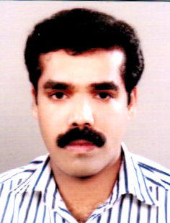
MOB: 9645411688, 8113001580
E-mail: rajanmudakkayathu@gmail.com

OBJECTIVE
To pursue an accelerating career where my skills can help improve the company’s overall performance and my professional development

PERSONAL INFORMATION
Name : Rajan.K.R
Address : Mudakkayath (House)
Cheruvally (Post)
Manimalla
Kottayam-Kerala-686543
Sex : Male
Date of Birth : 10.10.1980
Religion : Hindu
Nationality : Indian
Mother Tongue : Malayalam
Marital Status : Married
Contact Number : 9645411688, 8113001580
E-mail : rajanmudakkayathu@gmail.com

Languages known : Malayalam&English

Academic qualifications
- B.com (MG university course completed)
- Higher Secondary – MG University
- SSLC State board of Examination, Kerala

Computer knowledge
- M.S Office
- Tally ERP 9
Strength
- Courageous to take up a Challenges
- Ability to have a good communication with others

Experience

5 Years working as a Accountant in KALYAN SILKS in Kerala
- 2 Years Working as a Item Checking Staff in KITEX LTD ALUVA,in Kerala
- 3 Years Working as a Accounts assistant In Chartered Accountant Firm Kerala

Declaration
I am Declare that the all data given above are correct according to my knowledge and belief.

Place: Cheruvally
Date: 13/11/2019 RAJAN.K.R

