CURRICULUM VITAE

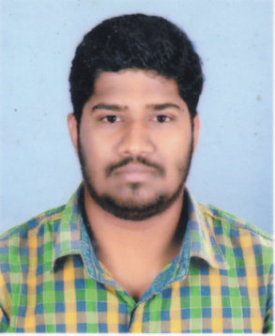
RAGESH BABU

Chaniyil
Kodamthuruthu
Kuthiathode P.O., Cherthala
Alappuzha (Dist)
Pin. 688533

Mob: 9249326156
E-mail. rageshbabu1814@gmail.com

CAREER OBJECTIVE

To associate with an organization which progresses dynamically and gives me a chance to improve my knowledge, enhance my skills in the state-of-art technologies and be a part of the team that work towards the growth of organization.

KEY SKILLS
- Good Communication Skill
- Committed to goals, ability to learn, good to lead the team
- Hardworking mentality
- Patient and competent
- Ability to rapidly build relationship and set up trust.
- Confident and determined

ACADEMIC QUALIFICATION

Course | Board/ University | Year of Pass | Percentage of Marks
B Com  Computer Application | M G University | 2015 | 2.14 (Weight)
Plus Two  Commerce | Kerala Board of Higher Secondary Education | 2012 | 72%
SSLC | Kerala State Board | 2010 | 66%

Computer Knowledge

- Tally ERP-9
- MS Word
- Excel
- Sap Business One

PERSONAL PROFILE

Name : Ragesh Babu
Father’s name : K.Babu
Age & Date of Birth : 22 yrs., 05.05.1995
Sex : Male
Religion & Community : Hindu, Ezhava
Marital Status : Single
Nationality : Indian
Permanent Address : Chaniyil
Kodamthuruthu Kuthiathode P.O., Cherthala
Alappuzha, Kerala (State)
INDIA
Phone Number : 9249326156
E-mail Id : rageshbabu1814@gmail.com
Language Known : Malayalam, English, Hindi

EXPERIENCE

- 10 months of experience as a Junior Assistant in KSEB Ltd.
- 1 Years of Experience as an Accountant in Kerala Goods Movers
- 1 and 5 months experience as an Accountant in Indus Motors Pvt.Ltd.

DECLARATION

I do hereby declare that, the particulars given above are true and correct in best of my knowledge & belief.

Place : Kuthiathode
Date RAGESH BABU

