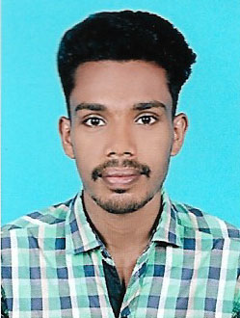
RESUME
ACHU CHACKO
SHEEMA BHAVAN
SANTHIPURAM
MEEYANNOOR PO
KOLLAM, KERALA- 691537
Mob : 7356659258, 8921830581
CAREER OBJECTIVE

To make contribution to the organization to the best of my ability and to develop new skills and share my knowledge while interacting with others and achieve new heights.

EDUCATIONAL QUALIFICATION

- Passed DIPLOMA IN PHARMACY in 2018 under Directorate of Medical Education from AYISHA MAJEED COLLEGE OF PHARMACY.
- Passed HSE from T.V.T.M.H.S in 2013 under Higher Secondary Board with 74 %.
- Passed ICSE from S.D.A SCHOOL, KOTTARAKARAarein 2011 under Kerala State Board with 62 %.

STRENGTH AND SKILL

- Communication Skill
- Listening Skill
- Interpersonal Skill
- Adaptability
Name : ACHU CHACKO
Father’s Name : Chacko Thomas
Date of Birth : 27-02-1996
Gender : Male
Religion : Christian
Nationality : Indian
Languages Known : Malayalam, English
Marital status : Single
Hobbies :Travelling and reading books, Listening
Music
PRACTICAL TRAINING DETAILS

3 Month Training Period under ESI Model Super Specialty Hospital, Asramam, Kollam.
I hereby declared that all the above furnished details are true to the best of my knowledge and beliefs.
Place :
Date : ACHU CHACKO

