CURRICULUM VITAE
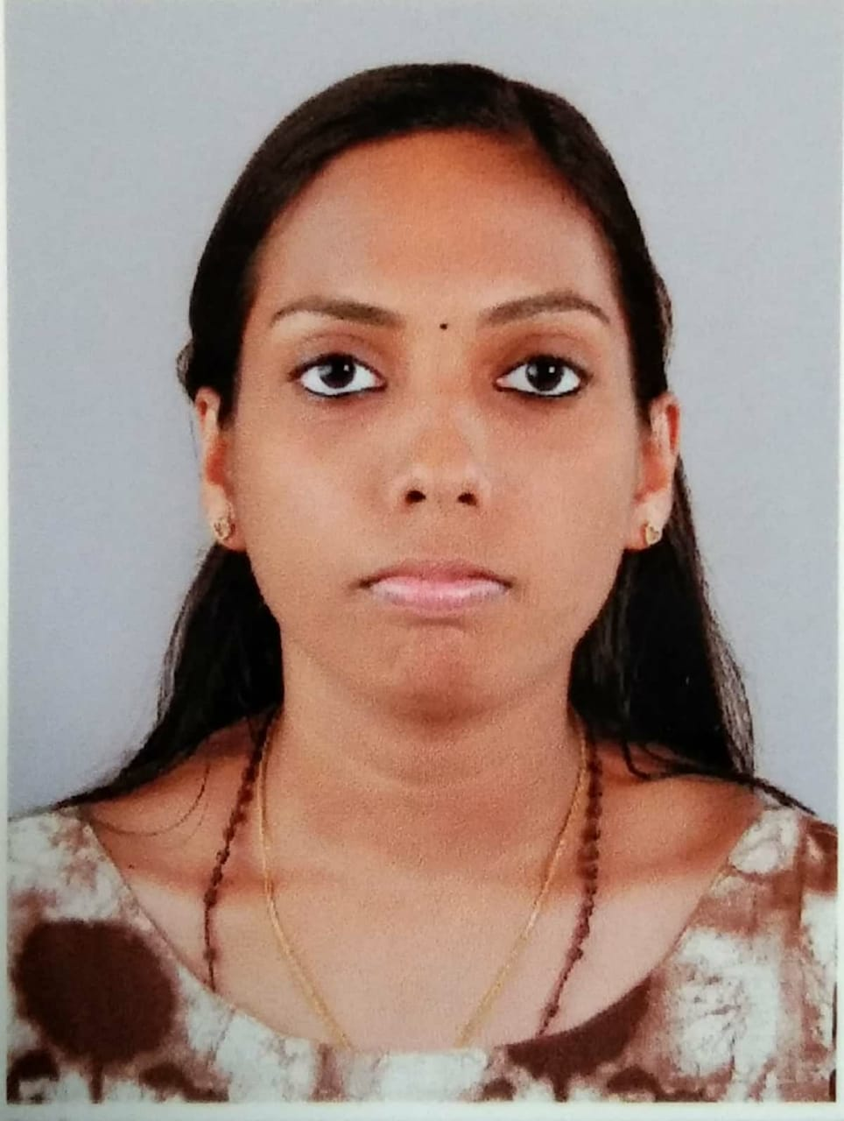
Ms.CHINNUTTY FRANCIS
Koomullil House
Amballoor P.O
Pin -682315
Ernakulam
Kerala
Ph.No –9526538586
8075736047
Email-chinnuttyfrancis528@gmail.com

PERSONAL DETAILS

FATHER’S NAME
Mr.Francis
MOTHER’S NAME
Mrs.Kunjumol Francis
DATE OF BIRTH
09/10/1996
GENDER
Female
NATIONALITY
Indian
MARITAL STATUS
Single
LANGUAGES KNOWN
Malayalam,English,Hindi
RELIGION
Christian

CARRIER OBJECTIVE
Dedicated reliable, skilled, ethical health care worker with ability to stay calm and intervene during crisis , facilitate groups and educational seminars and collaborate on multidisciplinary terms looking staff nurse position in a reputed health care provider.

ACCADEMIC QUALIFICATIONS
St.Ignatious V.H.S.S Kanjiramattom March
Secondary school leaving certificate 2012
96%

St. Ignatious V.H.S.S Kanjiramattom March
Board of higher secondary examination 2014
88%

Jubilee mission college of nursing 2014-
Bsc Nursing 2019
71%

WORKSHOP ATTENDED
Aroad to excellence in nursing service: Need for the hour
CPR and AED skills

STRENGTHS
- Highly achievement oriented and an ability to develop effective strengths

- Strong leadership skills with an ability to build ,develop and result oriented trams

- Confidence and hardworking
- Punctuality and positive attitude
- Optimistic
- Communication skill
- Loyal towards my work and duties

REFERENCE

- Dr.Angela Gnanadural
Principal
Jubilee mission college of nursing
Thrissur
0487-2426709
9048285000

- Sr.Philoreshmi
Vice Principal
Jubilee mission college of nursing
Thrissur
9947584588

DECLARATION

I hereby declare that the above furnished details are true to the best of my knowledge and belief. I assure that I will discharge my duties to the best satisfaction of my superiors.

Place - Amballoor Chinnutty
Date -

