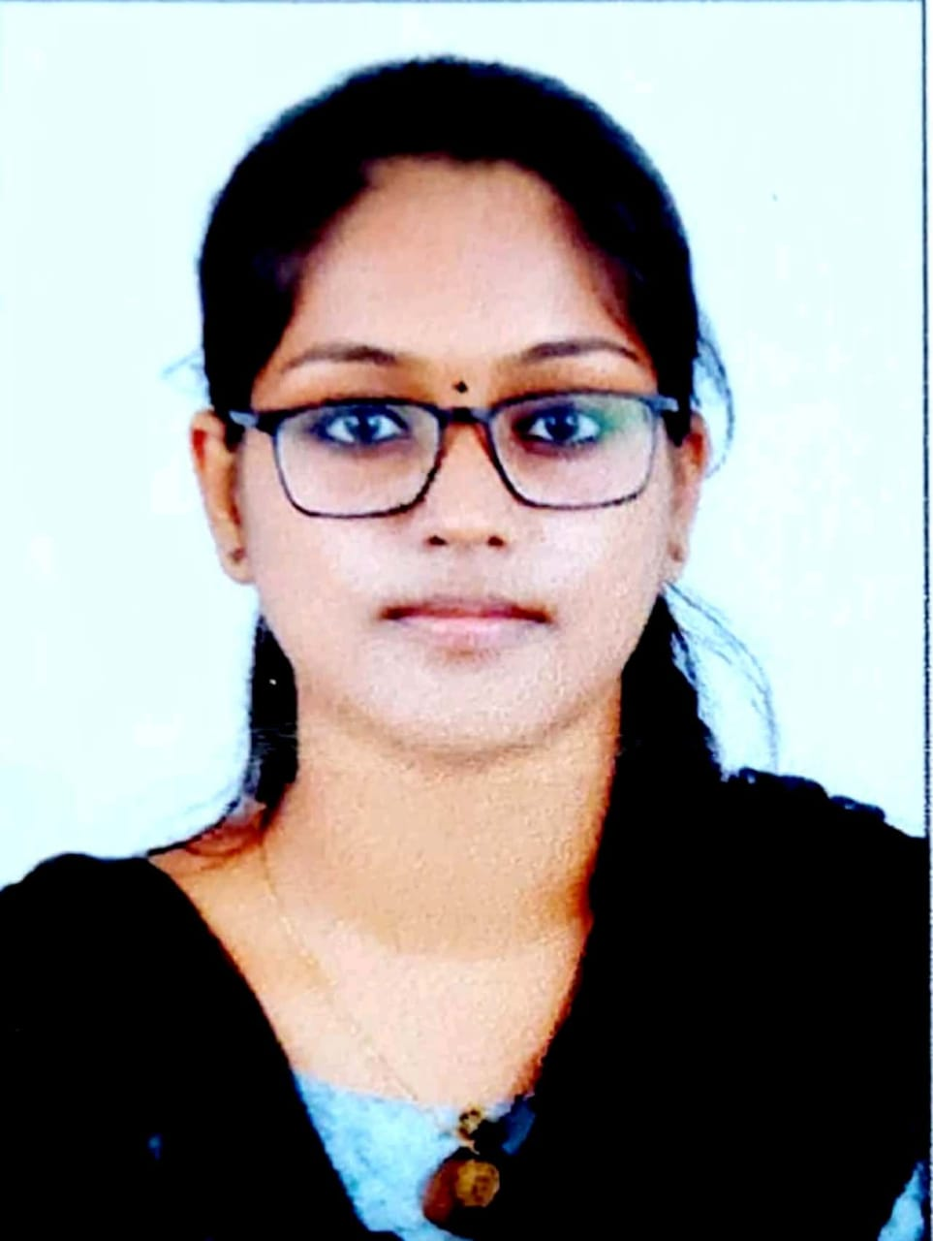
RESUME
V.Jayalakshmi
Email ID. : jayalakshmi1698@gmail.com
Contact No: 8606832039
Career Objective

To work for an organization which provides me the opportunity to improve my skills and knowledge to grow along with the organization objective.
Educational Details

QUALIFICATION | COLLEGE/INSTITUTES | UNIVERSITY/BOARD | YEAR | PERCETAGE/CGPA
SSLC | ST.KURIAKOSE PUBLIC SCHOOL ,KOTTAYAM | C.B.S.E | 2014 | 8.8
HSC | SMV NSS HSS  KALLARA,KOTTAYAM | KERALA STATE BOARD | 2016 | 88.5%
BSc MATHEMATICS | BISHOP KURRIALACHERRY COLLEGE FOR WOMEN, KOTTAYAM | MAHATMA GANDHI UNIVERSITY | 2019 | 7.92
Technical Skills

- Completed medical coding course at IIMC kottayam
- Basic computer skills(MS Office,internet usage).
Skill set

- Effective communication and interpersonal skills
- Ability to deal with people diplomatically
- Willingness to learn

Hobbies

- Playing games.
- Listening songs.
- Drawing and painting.
Personal Details

Date of Birth: 21st September 1998
Languages Known: English, Hindi, Malayalam and Tamil

Declaration

I hereby declare that all above furnished particulars are true to the best of my knowledge and belief
Place: Kottayam.

