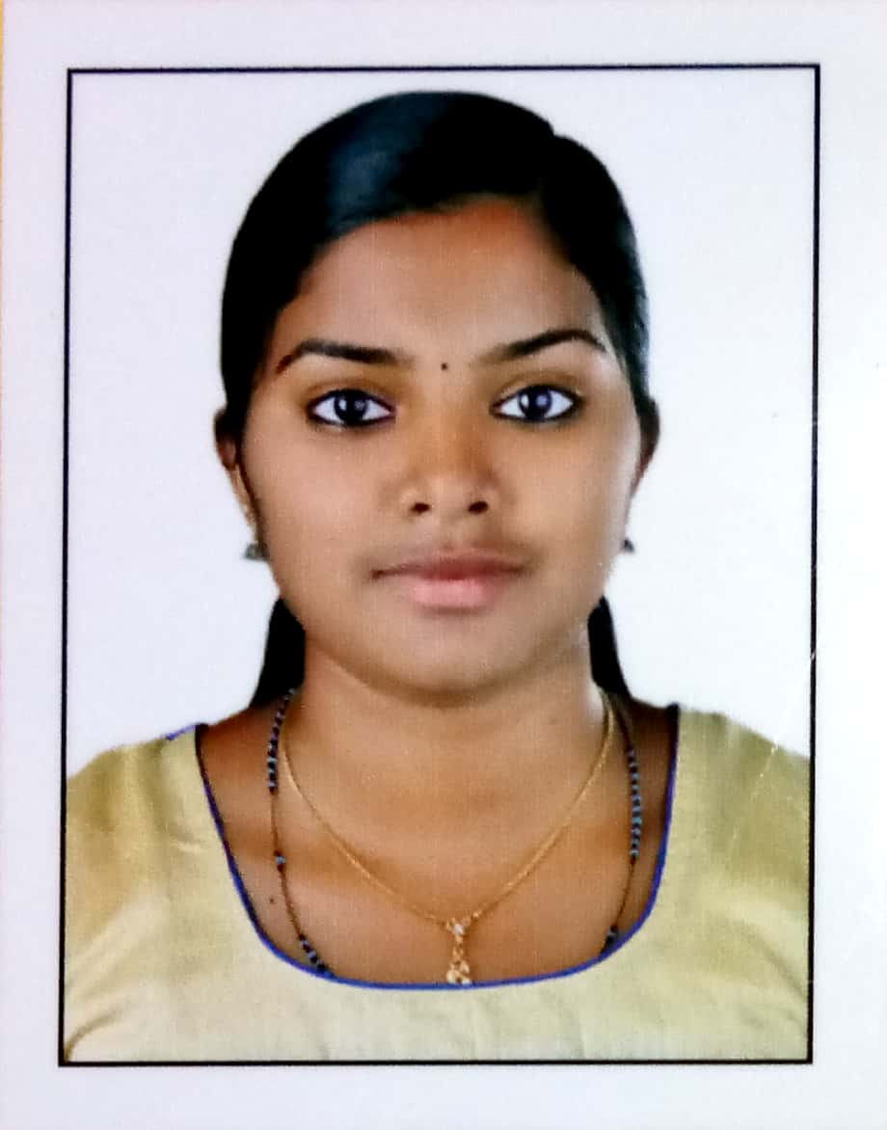

ROSMY JOLLY

STAFF NURSE IN NEONATAL INTENSIVE CARE UNIT

Mob: 9482184594
7510384594

Emai ID: rosmyjolly333@gmail.com

Career Objective:
To work for a dynamic health care institute, which has a transparent and pro-active environment that offers professional growth, where I can pro-actively contribute to the improvement of present function and growth with the institution while being resourceful, innovative and flexible. Thus gaining valuable knowledge and experience
Academic Achievements:
Qualification | Year Of passing | Board/University | From which institute passed
S S L C | 2009 | Board of public examination of kerala | St’Joseph’s Girls High School Arakuzha,Kerala
PUC | 2011 | Board of higher secondary examnation kerala | St’Augustian’s Girls Hgher Secondary school kothamangalam,kerala
B.Sc Nursing | 2016 | R G U H S | Rajarajeswari college of nursing Bangalore(Rajareswari medical college)

Work Experience
1. Sagar Hospitals at Tilak Nagar, Jayanagar Extn, Bengaluru. Since 3/4/2017 to 6/10/2017, I have specialized in caring for adult in the medical surgical ward.
. Bed capacity is 200 bedded world class (iso9001- 2008 & NABH certified state of the art /multi Specialty, Tertiary care Hospital in Bangalore, With latest high- tech diagnostic facilities and highly Qualified

2. Rainbow Children's Hospital, Road no:178/1 & 178/2 ,opposite Janardanan towers,bilekahalli,bennargatta road, Bangalore, karnataka.Since 18/05/2018 to 30/08/2019, I have specialized in caring for neonates in the Neonatal Intensive Care Unit.
Bed capacity is 100 bedded hospital,NABH certified and tertiary care hospital in Bangalore with latest high standards of technological and diagnostic facilities.

EXPERIENCE IN PERFORMANCE OF :

- Assessment of the patient.
- Attend the patient’s physical and psychological needs.
- Management of IV Fluids, blood transfusion.
- Insertion of I.V Cannula, Urinary Catheter and removal
- Oxygen administration, suctioning, steam inhalation, nebulization, care of patient on bi-pap and Tracheostomy care.
- Collection of specimen collection.
- Taking ECG monitoring.
- Maintaining I/O Chart
- R.T Feeding and oral feeding, PEG feeding.
- Administration of medication through I.V and I.M.
- Maintaining records of patient care.
- Preparing the patient for surgery.
- Administration of post-operative medication.
- Prevention and treatment of bed sores.
- Admits and discharges of patients.
- Maintains personal hygiene comforts the patient.
- Taking care of I.V lines CVP & ICD.
- Supervising proper disposal of biomedical wastage in units.
- Receiving the patients from OT and casualty and Carrying out orders.
- Observes changes in patient’s conditions and take necessary action.
- Accompanies very ill patients sent to other Departments or transferred to other Institutions.
- Know to secure arterial line and jugular line
- know to manage the department and to do its analysis

Computer Knowledge:
. Basic fundamental
. MS office Internet Browsing&Mailing

Areas of strength
- A positive attitude inculcated in performing any given task.
- Maintaining good interpersonal relationships with team members and patients
- Delight the customer with high quality service under any circumstances.
- Maintaining high standards by improving/increasing productivity and efficiency in work
- Dedicated to work long hours when the need arises with high standard leadership qualities
- Strong ability to learn fast and adjust in the new environment, while keeping in mind the current professional environment and resources
- HOBBIES AND INTEREST
Singing, listening to music & Watching Movie
Internet surfing, Reading, Drawing

PERSONEL DETAILS:
Name : ROSMY JOLLY
Father’s name : JOLLY MATHEW
Date of birth : 04-05-1994
Gender : Female
Place of Birth : kothamangalam
Marital Status : Single
Nationality : Indian
Religion : Christian
Mother Tongue : Malayalam
Blood Group : O Negative
Height : 5.4 inch(159cm)
Weight : 52 kg
Registration No : 079940
Date of Registration: 17-02-2017

Permanent Address :
Punnackappadavil (H),
Mullaringadu (P.O),Vannappuram (V),
Thodupuzha (TH), Idukky(Dist),
Kerala state, PIN-685607
India
Contact Number : 9482184594,7510384594
E-Mail : rosmyjolly333@gmail.com
Languages known : English, Hindi, Malayalam, Kannada, Tamil

PASSPORT DETAILS :
Passport number: N7626307
Date of Issue : 15-02-2016
Date of Expiry : 14-02-2026
Place of Issue : Cochin

REGISTRATION OBTAINED
- Karnataka State Nursing Council
Registration number : 079940
Date of registration :17-02-2017

DECLARATION

Given an Opportunity, I will strive for Quality and efficient work with obedience and sincerity to work as my main goal.

Yours truly,

ROSMY JOLLY.

