CURRICULAM VITAE
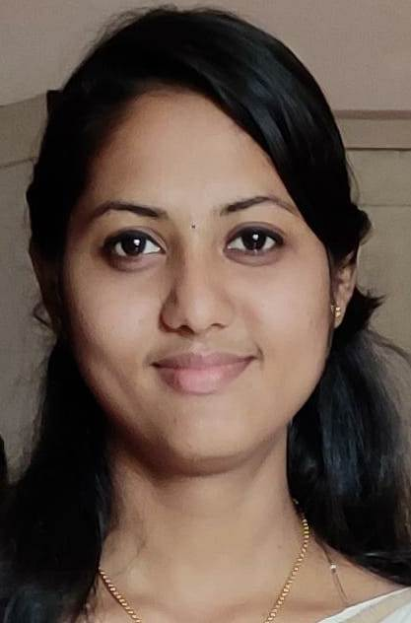
JINY ELYZABATH JACOB
Punnekkattu house
T V Puram P O
Vaikom
Kottayam
Kerala, INDIA, 686606
E-mail: jinyelyzabathjacob@gmail.com
Phone: 9072294017

CAREER OBJECTIVE:

To obtain a full time position as a staff nurse where I can contribute my skills and education in a challenging environment.

PERSONAL DETAILS:

Sex : Female
Date of Birth : 20-12-1997
Religion : Christian
Nationality : Indian
Languages : English & Malayalam
Marital Status : Single

EDUCATIONAL QUALIFICATION

QUALIFICATION | INSTITUTION | BOARD/UNIVERSITY | YEAR OF PASSING
B.Sc Nursing | St Thomas College of Nursing Kattanam | Kerala University of Health and Applied Science | 2019
Plus Two | St. Little Teresa’s Girls Higher secondary School,Vaikom | Kerala State Board | 2015
SSLC | St. Little Teresa’s Girls High School, Vaikom | Kerala State Board | 2013

INTEREST AND ACTIVITIES

- Clinical Practice
- Reading Books
WORKSHOP CONDUCTED

Nursing Education Workshop on “Method of Teaching”

INTEREST AND ACTIVITIES

- Seminar on hand washing
- Medical camp on communicable and non communicable disease.
- Poster presentation on prevention of accident among children.
- Research on “Effectiveness of structured teaching programme on knowledge of mothers regarding malnutrition among under five children”.
- Community research on “Effectiveness of structured teaching programme on knowledge of mothers regarding prevention of accident among the under five children in selected areas of Kappil.”
- Continuing Nursing Education programme on “A Quality approach towards drug administration.”
AREAS OF CLINICAL EXPOSURE
- Emergency Department (Casualty) – Government Hospital Kayamkulam,St Thomas Mission Hospital Kattanam,VSM Hospital Mavelikara.
- Intensive Care Unit – Government Hospital Kayamkulam,St Thomas Mission Hospital Kattanam,VSM Hospital Mavelikara.
- Medical & Surgical Ward – Government Hospital Kayamkulam,St Thomas Mission Hospital Kattanam,VSM Hospital Mavelikara.
- Neo Natal ICU & Pediatrics – Life Line Hospital Adoor
- Operation Theatre – Government Hospital Kayamkulam, St Thomas Mission Hospital Kattanam.
- Obstretics & Gynecology– Ebenezer Hospital Kayamkulam,St.Thomas Mission Hospital Kattanam.
- Cardiology department – St.Gregorios Medical Mission Hospital Parumala .
- Oncology Department – Regional Cancer Centre Trivandrum.
EXTRA CURRICULAR ACTIVITIES
- Active participation in various events in college and managed various cultural events in school and college level.
DECLARATION
I hereby declare that all the statement made are correct and complete to the best of my knowledge and belief.

Place: Kottayam JINY ELYZABATH JACOB
Date:

