RESUME

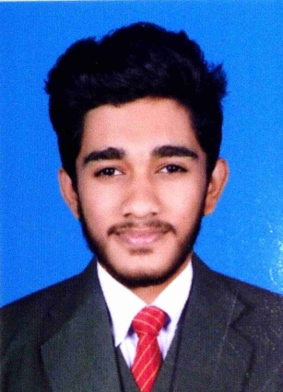
JISHAR .T
THATTARASSERI HOUSE
RAMANKUTH PO
NILAMBUR
MALAPPURAM
KERALA, INDIA
PIN-679330
M0b: +91-9633413330
+91-8075795754
Email –jishujishar330@gmail.com

POST FOR CSSD TECHNICIAN
Professional Objective
To render an international quality service by contributing effective and productive service on evidenced based practices through meticulously planned dedicated work and to keep team spirit to archive the organizational goals.
Background Summery
A professional with 2year CSSD course completed under Medwin Institute of Medical Science, Recognized Telangana State Paramedical Board .
Promoted by Govt. of India
- Reprocessing instruments (Decontamination, Cleaning, Aeration)
- Assembling and packing instruments with appropriate indicator.

- Handling Sterilizing techniques/ equipment s of Steam Sterilization, EO Sterilization and Plasma Sterilization.

- Storing of sterile materials and distribution

- Experience in handling instruments of Cardiac surgery ,Neuro surgery, Plastic surgery , Uro surgery , Ortho surgery, Endoscopic instruments, General surgery, ophthalmic surgery , OBG surgery, ENT surgery ,Dental surgery, Cathlab instruments and other regular surgical instruments and devices.

Academic: Educational Qualification
# DIPLOMA IN CSSD WITH OT (Medwin Institute of Medical Science - 2017-2019)

# PLUS TWO (Under Higher Secondary Examination – 2017)

# SSLC (under – Board public examination Kerala – 2015)
Personal Details

Name - Jishar .T

Date of Birth - 29.04.1999

Father - Jahamgeer .T

Mother - Saudhabi

Religion / Cast - Islam,Mappila, OBC

Blood Group - O+ve

Gender - Male

Marital Status - Single

Languages - English (read, speak, write)

- Hindi (read, write)

- Malayalam (read, speak, write)
Personal Traits
Good communication skills, likes talking Up Responsibilities, Strong belief in team work
And committed workman ship. Quick learner, personality hardworking, confident and leadership quality
Professional Interests and Activities
Aspiring to continue further education / learning and widen the horizon of knowledge
Declaration
I hereby declare that the above information is true and correct to the best of my knowledge
And belief
Date: 17/06/2019
Place: NILAMBUR JISHAR.T

