SUKANYA S
OBJECTIVE
To work for a well known organization to showcase my skill and talent to aid my future in the field of Pharmacy.

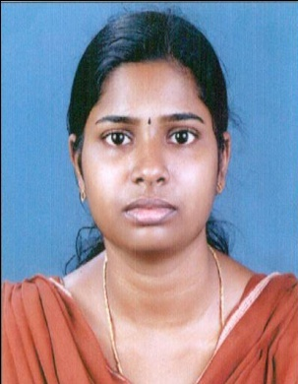

Educational Attainments

PHONE

1. D.PHARM:
Diploma in Pharmacy course completed from Sree Narayana Guru Memorial College of Pharmacy (SNGM), Thuravoor, Alappuzha, Kerala.
University: Government of Kerala Directorate of Medical Education 2017

2. HSC:
Scored 68% aggregate of marks from T.D Higher Secondary School, Thuravoor, and Cherthala.
2008 – 2010

4. SSLC:
Scored 80% aggregate of marks from Government Girls Higher Secondary School, Cherthala.
2008

5. Computer Proficiency:
C++, MS Office, PowerPoint, DTP, Photoshop.

8075223012
8547592955

EMAIL
sukanyaanusha78@gmail.com

PERMANENT ADDRESS
Kollelinikarthil, Pattanakkad P.O.
Cherthala, Alappuzha (Dist.)
Kerala, India. Pin: 688 531

PERSONAL DETAILS

DOB : 17th April 1992
Nationality : Indian
Sex : Female
Marital Status : Married

LANGUAGES KNOWN
- English
- Hindi
- Malayalam

Work Experience

- 3 months Apprentice Training Program as a Pharmacist Aide at Cherthala Govt. Hospital,
Alappuzha, Kerala.
- 1 Year and 5 months Worked as a Pharmacist at Providence Hospital, Thumpoly , Alappuzha during the period 2017 Dec to 2019 April .

STRENGTHS

- Honest
- Aggressive
- Quick Learner

HOBBIES & INTERESTS

- Travelling
- Listening Music
Acknowledgement

I hereby assure that the above details provided are true, correct and complete to the best of my knowledge.

Place: Cherthala
Date:
SUKANYA

